# ***Artificial Vision System for Meat Quality Gradation***

## ***B. Tech. Project Report***

# *By*

### 

### ***Name of the B. Tech. Students***

# 

# ***Shubhodeep Chanda***

# ***Arunima Chaudhuri***

# ***Debdoot Roy Chowdhury***

# ***Bidesh Banerjee***

# 

# ***Under Supervision***

# ***of Kingshuk Chatterjee***

# 

**Department of Computer Sc. and Engineering**

**Government College of Engineering and Ceramic Technology**

## 

## **Kolkata**

**April 2023**

# ***Artificial Vision System for Meat Quality Gradation***

### ***A Project Report***

*Submitted in partial fulfillment of the requirements for the award of the degree*

***of***

### 

### ***Bachelor of Technology In***

***Computer Sc. and Engineering***

*By*

***Shubhodeep Chanda (GCECTB-R19-3026) Arunima Chaudhuri (GCECTB-R19-3008)***

***Debdoot Roy Chowdhury(GCECTB-R19-3014)***

***Bidesh Banerjee (GCECTB-R19-3013)***

# 

**Department of Computer Sc. and Engineering**

**Government College of Engineering and Ceramic Technology**

## 

## **Kolkata**

**April 2023**

#### **Name and Roll No. of the Students Signature of the Students**

1. Arunima Chaudhuri, GCECTB-R19-3008

2. Debdoot Roy Chowdhury, GCECTB-R19-3014

3. Bidesh Banerjee, GCECTB-R19-3013

4. Shubhodeep Chanda, GCECTB-R19-3026

**Place: Kolkata**

**Date:**

**Government College of Engineering and Ceramic Technology**

**73, A. C. Banerjee Lane, Kolkata, West Bengal 700010**

**…………………………………………………………………………………………**

**BONAFIDE CERTIFICATE**

Certified that this project report titled **Artificial Vision System for Meat Quality Gradation** is the realistic work carried out by **Arunima Chaudhuri(GCECTB- R19-3008), Debdoot Roy Chowdhury(GCECTB-R19-3014), Bidesh Banerjee(GCECTB- R19-3013), Shubhodeep Chanda(GCECTB-R19-3026)** who will carried out the project work under **my / our** supervision.

*…………………………………..*

**Kingshuk Chatterjee**

**SUPERVISOR**

Assistant Professor

Department of Computer Science and Engineering

Government College of Engineering and Ceramic Technology

Kolkata-700010

*………………………………….. …………………………………………*

#### **Dr. K. Saha Roy External Examiner**

#### **HEAD OF THE DEPARTMENT**

#### Assistant Professor & Head

#### Department of Computer Science and Engineering

#### Government College of Engineering and Ceramic Technology

#### Kolkata-700010

Abstract

This paper presents a system that utilizes digital image processing techniques with artificial intelligence methods to determine the freshness quality of the three most widely consumed meat in India chicken i.e. Chicken, Fish, and Prawn. The system employs various machine learning and deep learning algorithms to classify meat images as consumable or non-consumable based on their quality. To capture the differences in brightness, hue, saturation, and other colour attributes of the meat images, the system converts them from the RGB (Blue, Green, Red) colour space to the HSV (Hue, Saturation, Value) colour space.

In our study, we compare the performance of different classification methods on the meat datasets and find that deep learning models such as Convolutional Neural Networks (CNNs) and ResNet achieve the highest accuracy of about 90% on the chicken dataset. The use of deep learning models enables the system to effectively capture the complex features and patterns present in the meat images, leading to improved classification accuracy.

We also developed a mobile application using the Flutter framework that utilizes a Tensorflow lite version of the CNN model we trained. The application provides a user-friendly interface for consumers and businesses in the food industry to determine the quality and safety of their meat products by capturing and processing their images using a camera or gallery. The app is designed to work both online and offline, making it accessible and convenient for users in areas with limited internet connectivity.

Overall, the proposed system has the potential to be a valuable tool for individuals and businesses in the food industry, helping them to ensure the quality and safety of their meat products, and reducing the risk of foodborne illnesses. The results of this study demonstrate the effectiveness of machine learning and deep learning algorithms in the classification of meat quality based on digital images.

Introduction

A computer vision technique is used for gradation that involves processing an image and then applying a machine or deep learning model to analyze its features. The main advantage of this technique is that it does not require any physical contact or damage to the object being assessed, as it relies on photography and colour analysis. This technique can be used to evaluate the freshness of various products, such as fruits and vegetables, by detecting changes in their colour and texture over time. It is a fast and accurate way of assessing the quality and shelf life of perishable goods.

In our study, we aimed to evaluate the freshness of three commonly consumed types of meat in India, namely chicken, fish (Ompok Bimaculatus), and prawn fish (Decapterus maruadsi), using computer vision technique techniques. To achieve this, we employed a range of machine learning and deep learning models, including Naive Bayes, KNN, SVM, Random Forest, CNN, RNN and ResNet. Our datasets were initially in the RGB colour space, but we converted them to the HSV colour space to better capture colour information and separate it from luminance.

HSV is a colour system that closely mimics the way the human eye perceives colour. It consists of three components: Hue, Saturation, and Value. Hue describes the actual colour, such as red, blue, or yellow, while Saturation describes the intensity or vividness of the colour. The value represents the brightness or darkness of the colour, with values ranging from black to white. By using HSV, we were able to capture the nuances of colour more accurately and achieve better results.

We explained the conversion process of RGB to HSV, where the input data are the red, green, and blue signals for each pixel, and the output parameters are the hue, saturation, and value. This transformation allows us to separate image luminance from colour information, making it easier to work on or analyze the luminance of the image/frame. HSV is particularly useful when colour description plays an integral role in the analysis.

Our models achieved an average prediction accuracy of more than 80%. We thoroughly discussed the working principles of each of the models used in our study and analyzed which colour space worked best for each of the datasets. Our findings suggest that deep learning models such as CNNs and ResNets performed better than traditional statistical machine learning models, and HSV colour space outperformed RGB colour space in terms of accuracy.

The deep learning models also have faster training time and inference time than the machine learning models. CNN has the fastest training time of 2 minutes, followed by RNN with 3 minutes. The machine learning models take longer to train, ranging from 5 minutes to 15 minutes. The inference time of CNN is 0.02 seconds per image, followed by RNN with 0.03 seconds per image. The machine learning models have slower inference times, ranging from 0.05 seconds to 0.2 seconds per image.

We have demonstrated that deep learning models are more effective and efficient than machine learning models for evaluating the freshness of food image datasets. We have also shown that HSV colour space is more suitable than RGB colour space for capturing the colour features of food spoilage. Our work can be useful for food industry applications that require fast and accurate detection of food freshness.

We also developed a mobile application using the Flutter framework. The application is designed to be user-friendly and accessible for both consumers and businesses in the food industry. To make the application effective and accurate, we incorporated a Tensorflow lite version of the CNN model that we trained. This model helps the application to determine the quality and safety of meat products by processing the images captured by the user's camera or from their gallery. The application is not only easy to use but also designed to work both online and offline, making it convenient for users who may have limited access to the internet. This feature is particularly useful for users in areas with poor internet connectivity.

Overall, our mobile application provides a practical solution to the challenge of determining the freshness and quality of meat products. Its user-friendly interface and compatibility with both online and offline use to make it a useful tool for both consumers and businesses in the food industry.

A Survey of Recent Research

**1. Gradation using KNN**

**Trientin**[5] proposed the classification of beef’s freshness through the sensory analysis of the samples’ colour, using the K-nearest neighbours (KNN) model. The authors captured the samples’ images in a controlled environment, using a digital camera. RGB parameters were extracted and converted to HSV parameters to check the brightness difference. The overall accuracy of the model using KNN stands at 75%.

**Taheri-Garavand** [6] used a method based on the KNN to assess the common carp’s freshness (Cyprinus carpio) during storage on ice. Sample images were captured in a controlled environment. Parameters of the RGB, his, and L*a*b* color spaces were extracted from 1344 images of samples. The overall accuracy of the model using KNN stands to 90.48%.

**S Agustin** [7] exercised Beef Image Classification using K-Nearest Neighbor Algorithm for Identification Quality and Freshness. The authors converted the RGB to Binary image. A thresholding process was used to separate the pixels based on the gray level. Image segmentation/edge detection is done to increase the appearance between the boundary line of an area or object in the image. Then the Gray Level Co-Occurrence Matrix (GLCM) of the image is found. The K-Nearest Neighbor is used to classify objects, based on learning data that is close to the object, according to the number of their closest neighbors or k values. The proximity or distance of the neighbor is usually calculated based on Euclidean distance. The results showed that the performance of the system using the KNN method to identify the quality of meat based on color and texture can detect the type of beef and the amount of accuracy of 91.0667%.

**Christell Faith D. Lumogdang**[8] applied a studio-type chamber for capturing images and detecting gasses. The box is made up of glass with two fixed Light Emitting Diodes (LED) on both sides for proper lighting and ray distribution. Found in the center of the chamber ceiling is the mounted Raspberry Pi Camera which captures the sample pork meat placed on the raised flooring or platform below it. On the left wall of the case are the gas sensors, MQ-135 and MQ-136. Beside the studio-type chamber is the circuitry box, which rooms the Arduino Uno, Raspberry Pi 3, exhaust fan, and the 7-inch LCD monitor. The overall accuracy of the model using KNN stands to 93.33%.

**Kenan Lugatiman** [9] employed an app which used computer vision for RGB extraction and k-Nearest Neighbors (k-NN) algorithm for classification and Waikato Environment for Knowledge Analysis (WEKA) in terms of the number of hours from slaughter. The overall accuracy of the model using KNN stands to 86.76%.

**2. Gradation using Linear Regression**

**Sun, Young, Liu, Chen, and Newman** [10] investigated pork’s freshness through its color characteristics, observed in digital images. The study compared the performance of the traditional regression methods. Eighteen image color features were extracted from three different RGB (red, green, blue) models, HSI (hue, saturation, intensity), and L*a*b* color spaces. Two comparable regression models (linear and stepwise) were used to evaluate prediction results of pork color at- Tributes. The proposed linear regression model had an accuracy of 83%.

**3. Gradation using Logistic Regression**

**Nachiketa Hebbar** [11] utilized a sensor that measures the concentration of oxygen and ammonia levels in a food and a machine learning model using logistic regression is used to predict if the given food item is spoiled or not. It can also be deployed again to predict shelf life. The proposed linear regression model had an accuracy of 100%.

**4. Gradation using SVM**

**Xiao Guan** [12] suggest the following method - The steps of freshness assessment of meat samples based on QPSO-SVM are described as follows:

Step 1: Initialize the original data by normalization and then form a training sample set.

Step 2: Based on the RBF kernel function, call the embedded QPSO algorithm and get the optimal parameters. Construct the QP problem (equation 1) of SVM.

Step 3: Solve the optimization problem (equation 2) and compute the classification result according to equation 6.

The proposed SVM model had an accuracy of 92.8%.

**Arsalane** [13] presented the implementation of the principal component analysis (PCA) and support vector machine (SVM) models to classify and predict the freshness of beef. A data set of eighty-one beef images was analyzed based on the HSI color space. The beef images were captured in a controlled environment. The authors used the PCA model as a projection model and the SVM to classify and identify beef. The results obtained from the PCA projection model show the projection of three groups representing the freshness of beef meat during the days of refrigerated storage. The SVM model got a 100% success rate of classification and identification.

**Taheri-Garavand**[14] employed a method based on the SVM to assess the common carp’s freshness (Cyprinus carpio) during storage on ice. Sample images were captured in a controlled environment. Parameters of the RGB, HSI, and L*a*b* color spaces were extracted from 1344 images of samples. The overall accuracy of the model using SVM stands to 91.52%.

**5. Gradation using K-Means**

**Malay Kishore Dutta** [15] made an Image processing based method to assess fish quality and freshness.The RGB image is converted to Lab color space model. The Lab color space model is designed to approximate human vision and it suits the requirement to segment the gills from the fish image. K-means clustering algorithm works in 2 steps: Assignment phase and Update phase. Three clusters are formed. Feature extraction is done from the red channel in the wavelet transformation domain using. First, second and third level decomposition is performed.The statistical features of coefficients (mean and standard deviation) obtained at each level. The features extracted from horizontal coefficients at level 3 for all days of observation are analyzed for the variation pattern. The entire framework is used to divide the images into three freshness ranges. The accuracy obtained using this model is 95.833%.

**Winiarti** [16] harnessed identifying beef quality by sensory analysis of the color observed in samples photographed by a digital camera. The proposed system captures the sample image and calculates its’ RGB color space parameters. The authors used the histogram for each color channel in the sample to group 40 meat samples into four clusters, using the K-means model representing four categories: very viable, viable, less viable, or unfeasible. The determination of the categories is obtained based on the calculation of the Euclidean distance. The system classified forty meat samples, demonstrating that color parameters can group meat samples into different clusters. The accuracy obtained using this model is not given.

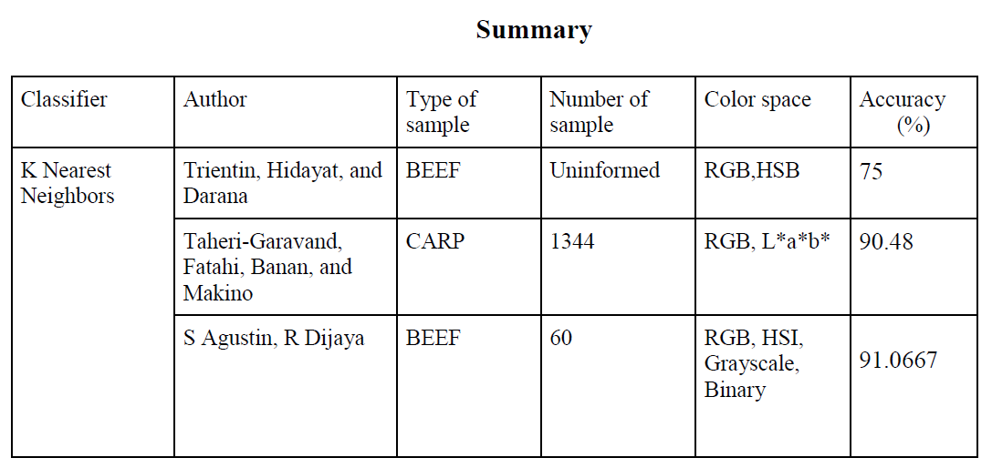

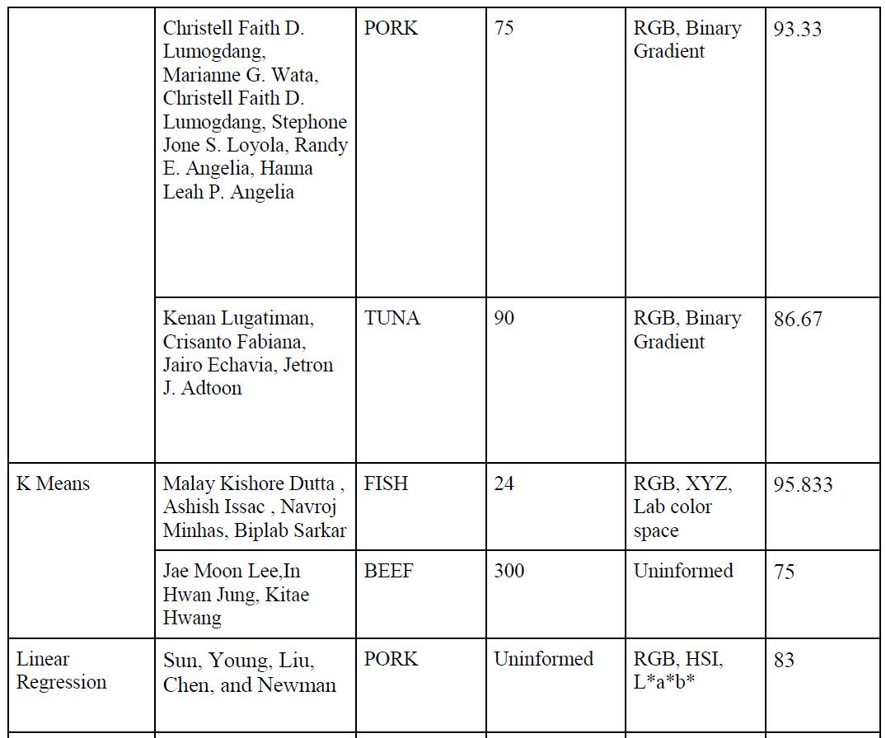

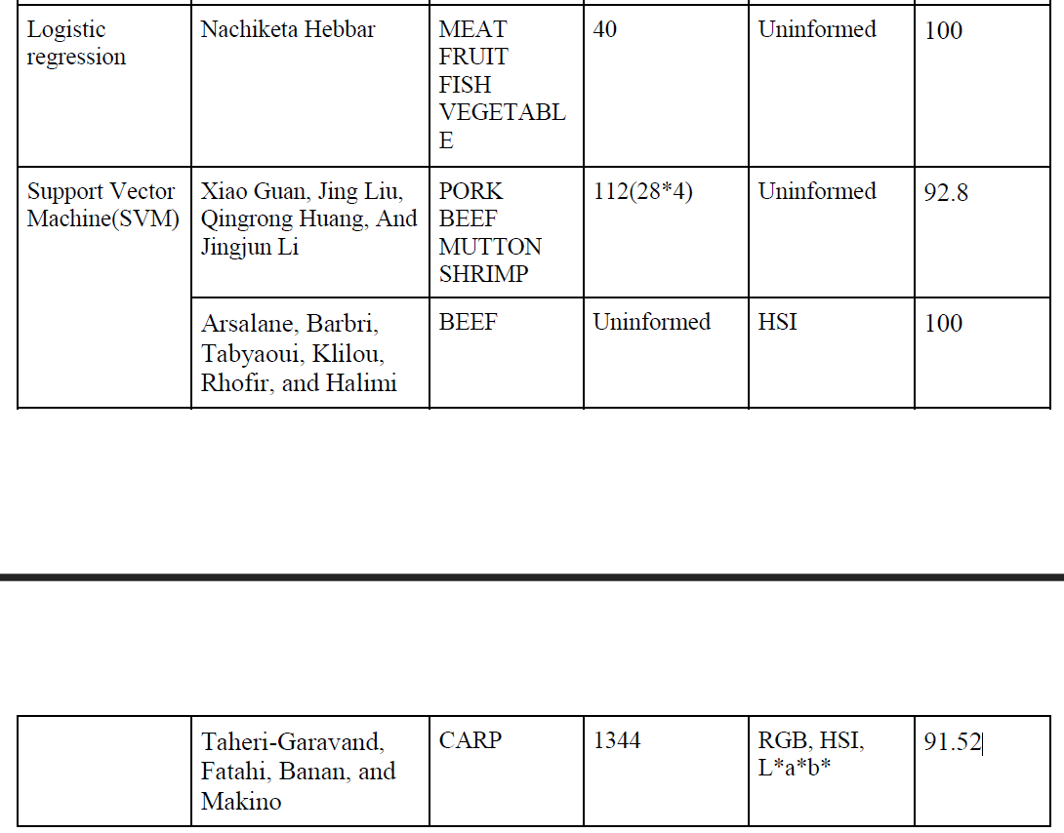

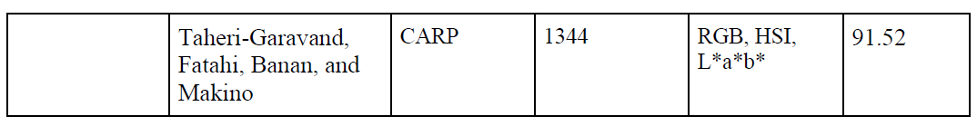

Table 1: Summary of the survey of the recent research papers

Dataset Preparation

1. **Fish** - The live Fish (Pabda) were sampled live from a local aquatic products market in Kolkata of India and kept in three hundred liters aquariums for 24 h. The average weight and average length of fishes were 90.40 ± 1.20 g and 21.60 ± 0.50 cm respectively. The pond water from which it was collected was free from any pathogenic infestation and toxic residues.  
   Fishes from the aquariums were taken out and placed into chilled water for sudden death to avoid rigor mortis. The fishes thereafter were preserved for imaging study in thermocol boxes (28 x 18 x 12 cm3) with a fish to ice ratio of 1:2. Images of fish were taken using a digital camera and the distance between the fish and the camera was as far as 10 cm. The captured images are of the size 601 x 361 pixels.

The fish images were captured starting from day one of death and at every two days' interval till the 10th day. Fish was stored in a freezer in the intermediate days with a temperature of 0 degree Celsius. Fish images classified as consumable (Refer Fig 1.1.1) were taken till 4-5 days from day one of death, and fish classified as non-consumable (Refer Fig 1.1.2) were taken from 5-6 days of death till the 10th day. The process of taking the image of fish meat is carried out in an open area which is illuminated by the natural sunlight. After the process of taking the image data, a certain part of the image object would be cropped[4].

The proposed image processing based method of freshness identification in fish samples involves feature extraction from the color difference in stomach area. To extract the accurate and discriminatory features from the image, the portion of the image which contains maximum information is required to be segmented from the whole image. After the process of taking the image data, the RGB image is then converted into HSV [17] (Refer Fig 1.1.3 and 1.1.4) images for both categories due for further processing.

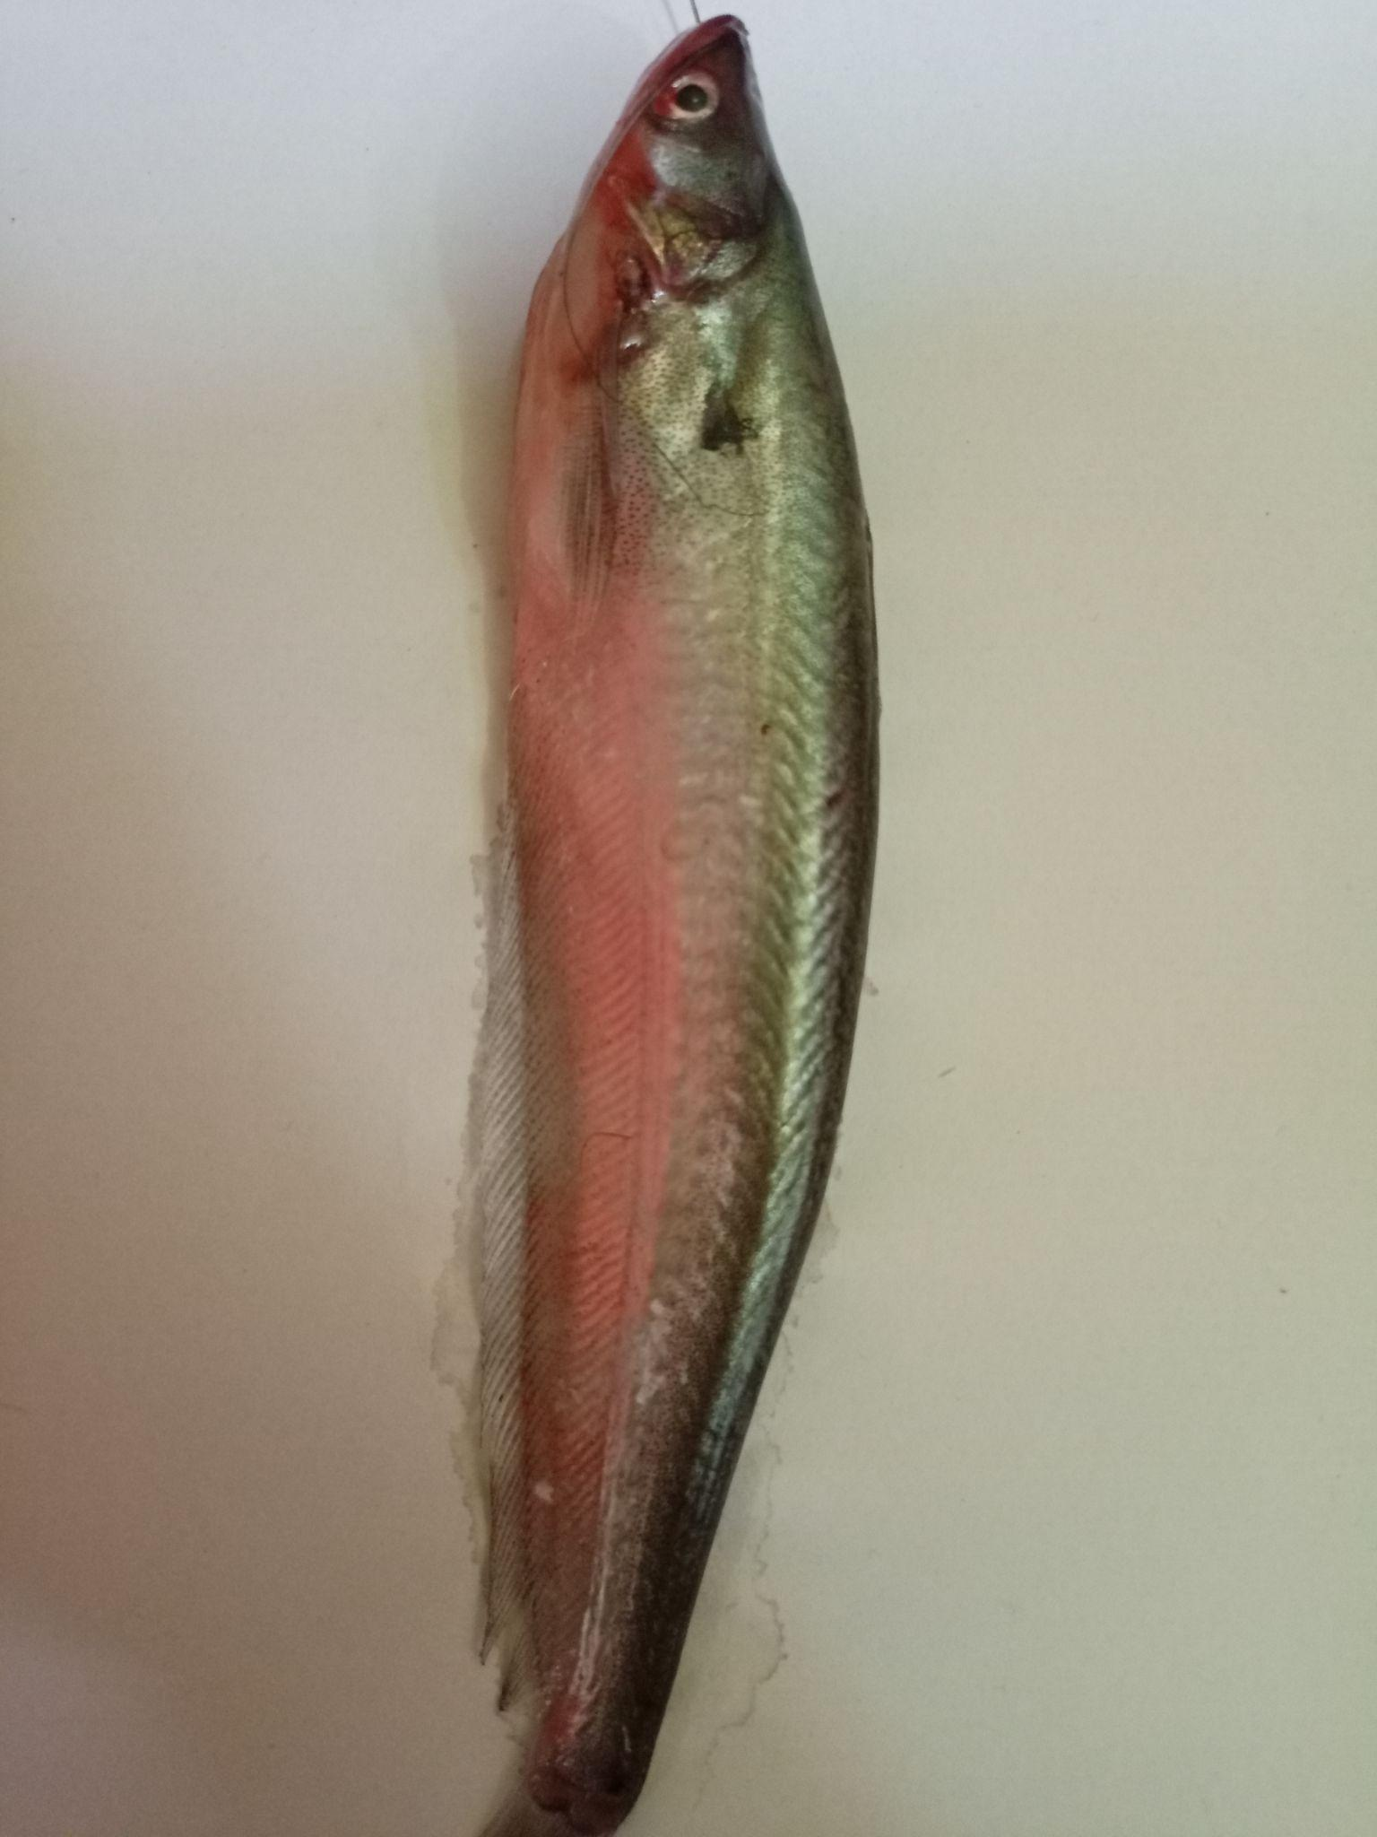 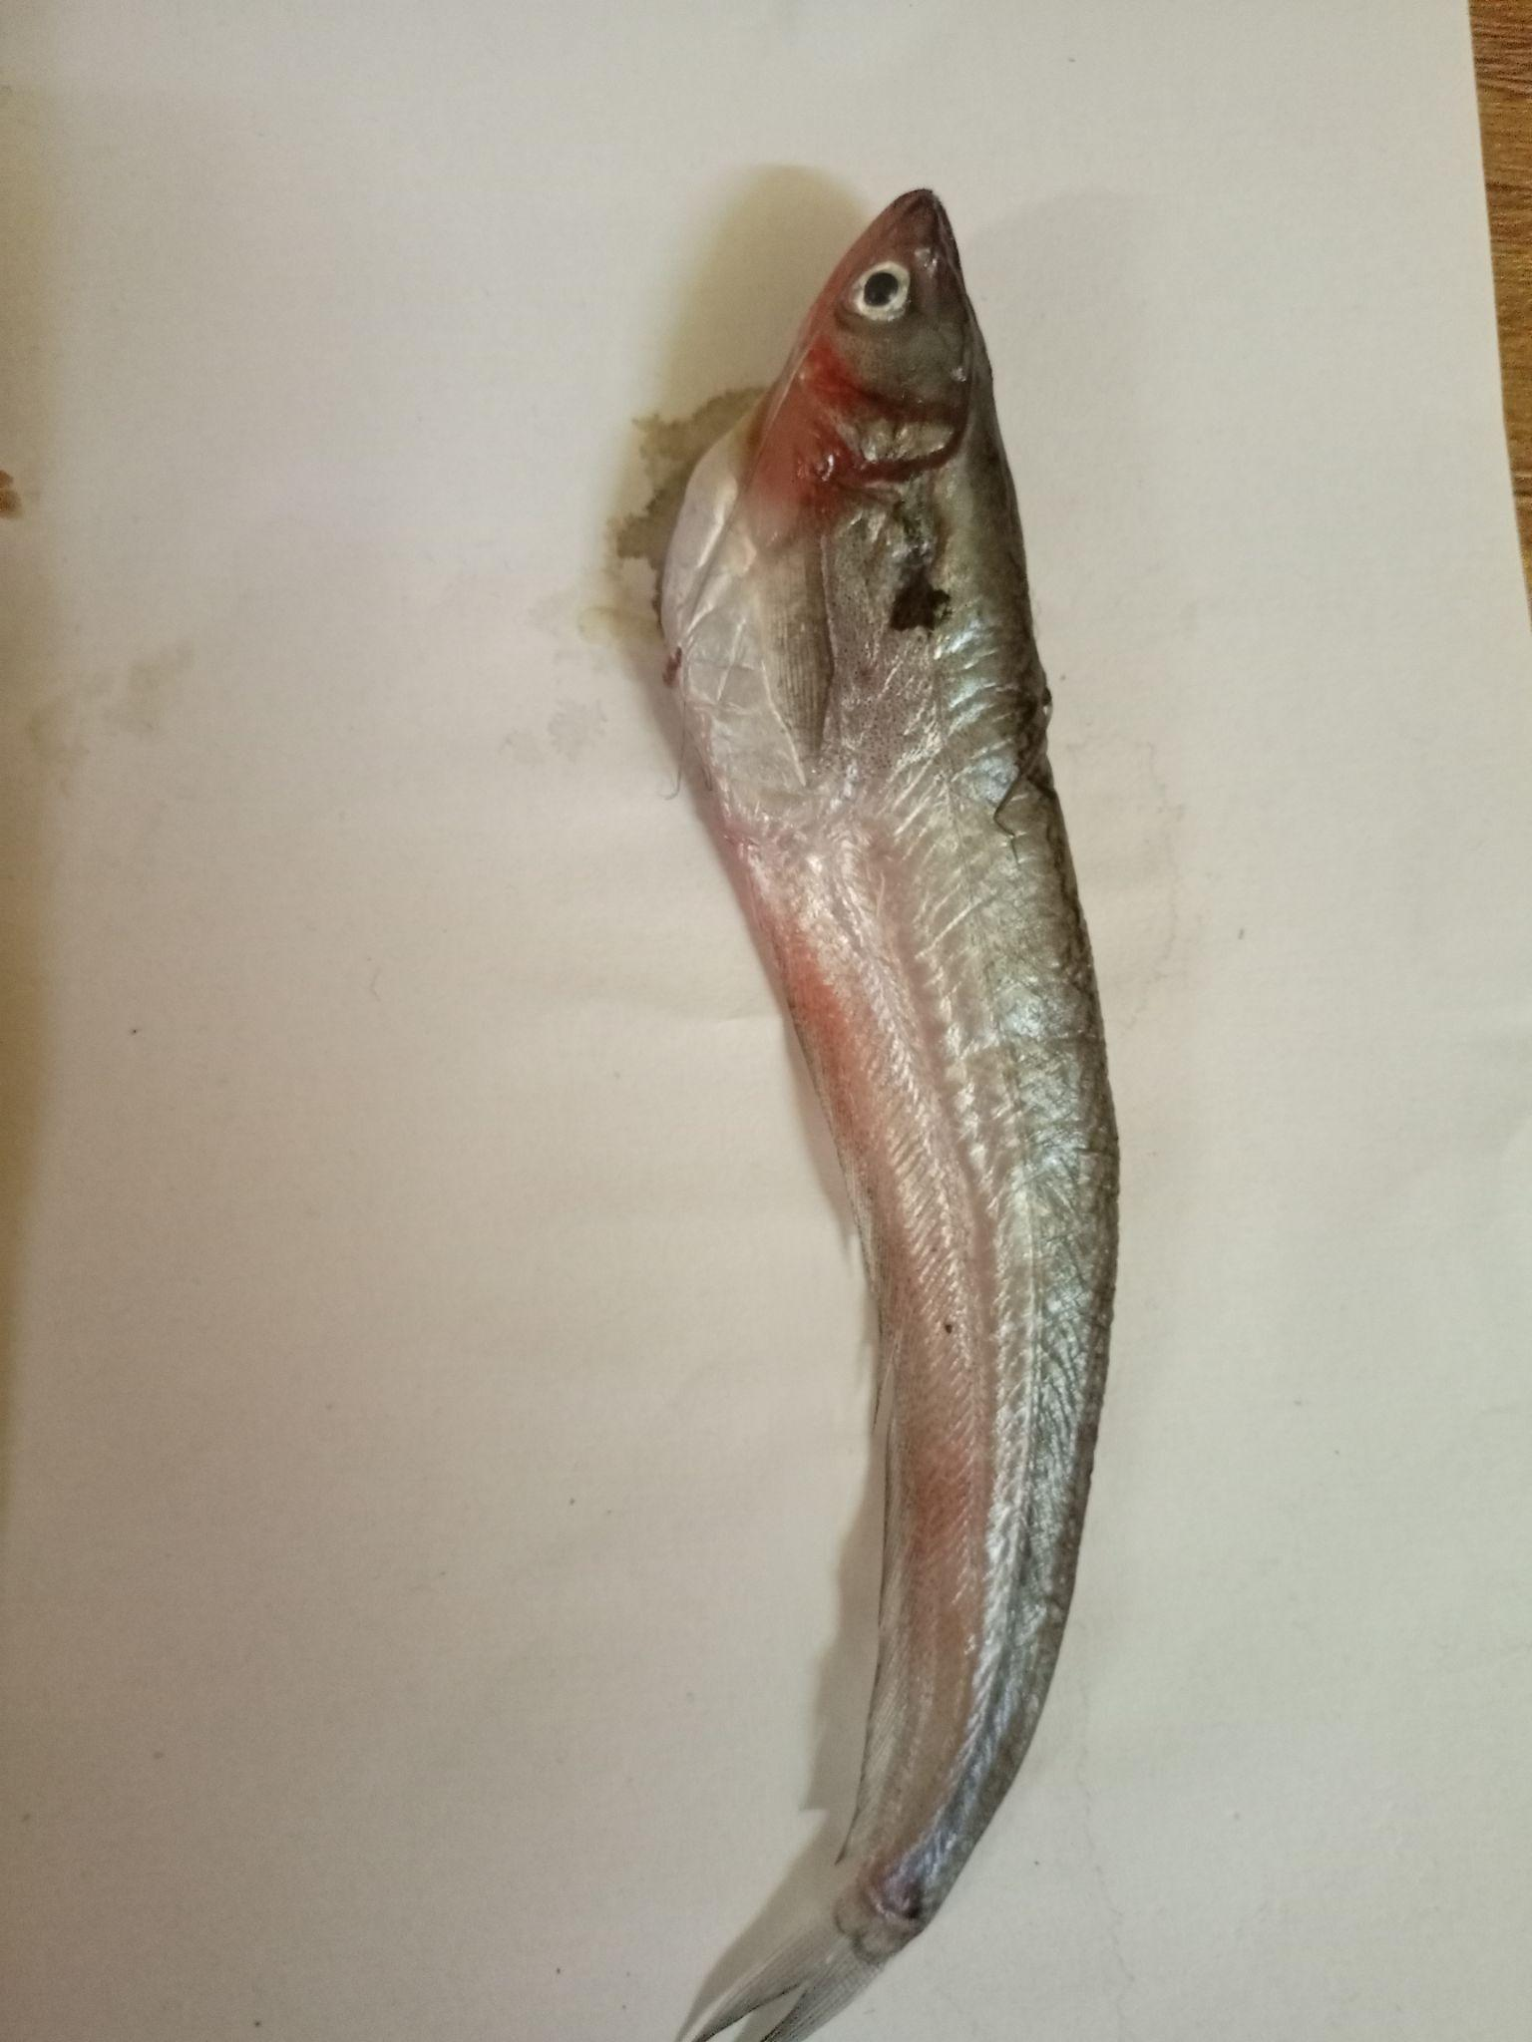

Fig. 1.1.1 Consumable Fig. 1.1.2 Non-consumable

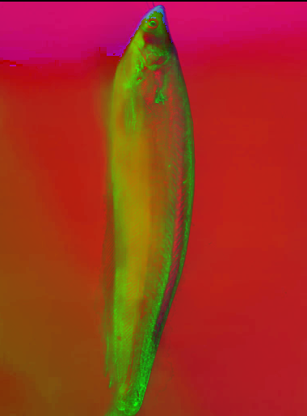 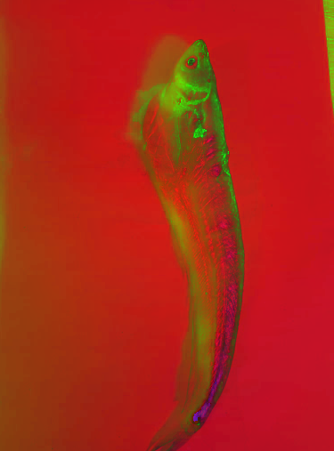

Fig. 1.1.3 Consumable (In HSV) Fig. 1.1.4 Non-Consumable (In HSV)

1. **Chicken** - The chicken meat was sampled from a local market where the chicken was brought alive from a nearby poultry. Breast meat portion was used as a sample for the dataset. The chicken breast is cut to various lengths and widths but with almost uniform thickness, approximately 0.5 cm. The process of capturing chicken meat image data used a digital camera and the distance between the chicken meat and the camera was as far as 10 cm. The captured images are of the size 601 x 361 pixels.

The chicken meat images were captured starting from day one of slaughter and at every two days' interval till 13th day. Meat was stored in a freezer in the intermediate days with a temperature of 0 degree Celsius. Meat images classified as consumable (Refer Fig 1.2.1) were taken till 5-6 days from day one of death, and meat classified as non-consumable (Refer Fig 1.2.2) were taken from 5-6 days of death till the 13th day. The process of taking the image of chicken meat is carried out in an open area which is illuminated by the natural sunlight. After the process of taking the image data, a certain part of the image object would be cropped.

The proposed image processing based method of freshness identification in chicken meat samples involves feature extraction from the color difference. [3] To extract the accurate and discriminatory features from the image, the portion of the image which contains maximum information is required to be segmented from the whole image. After the process of taking the image data, the RGB image is then converted into HSV [17] (Refer Fig 1.2.3 and 1.2.4) images for further processing [3].

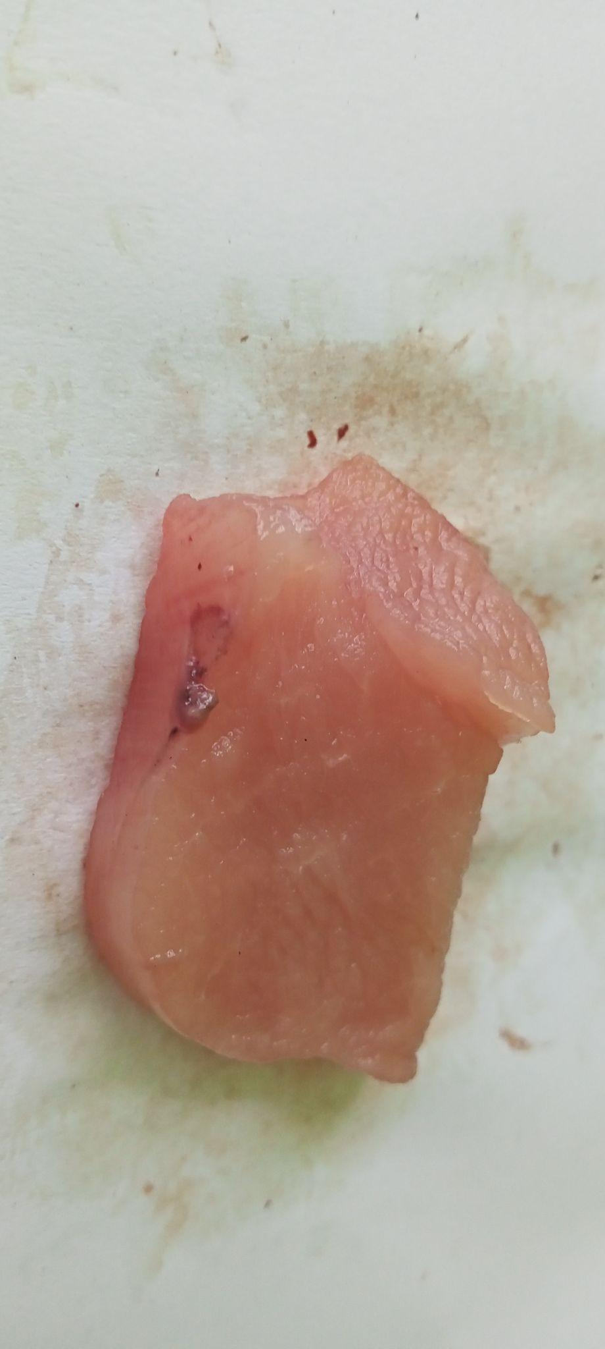 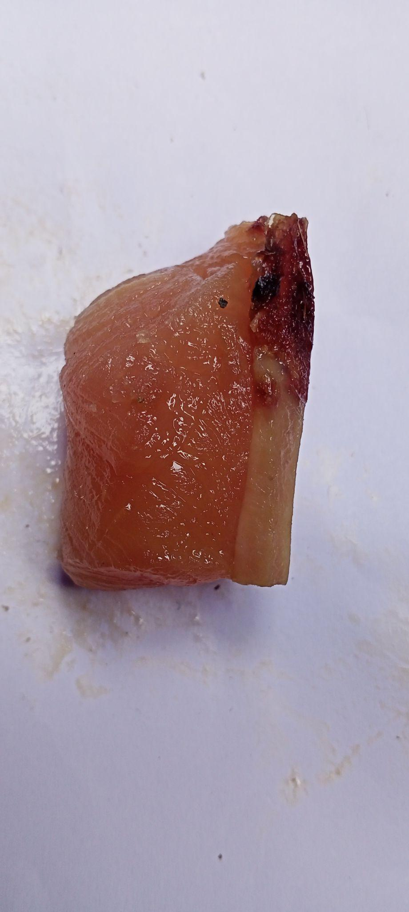

Fig. 1.2.1 Consumable Fig. 1.2.2 Non-Consumable

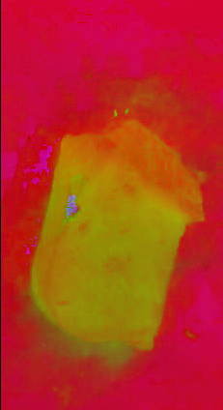 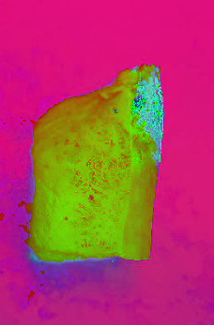

Fig. 1.2.3 Consumable (In HSV) Fig. 1.2.4 Non-Consumable (In HSV)

1. **Prawn** - Fresh whiteleg prawn each of approximately 24 ± 2 g in weight and 17 ± 2 cm in length were sampled from a local aquatic products market Kolkata of India. The shrimp were kept in seawater with ice and were transferred to the laboratory within 2 hours of purchase. After prawn with signs of visual defect or breakage were removed, the remaining shrimp were picked out. The shrimp were washed clean with tap water. The meat sample was collected immediately by hand with gloves to prevent contamination.

The prawn images were captured starting from day one of purchase and at every one day interval till 7th day. It was stored in a freezer in the intermediate days with a temperature of 0 degree Celsius. Images classified as consumable (Refer Fig 1.3.1) were taken till 3-4 days from the day one of death, and images classified as non-consumable (Refer Fig 1.3.2) were taken from 3-4 days of death till the 7th day. The process of taking the image of prawn is carried out in an open area which is illuminated by the natural sunlight. After the process of taking the image data, a certain part of the image object would be cropped.

The proposed image processing based method of freshness identification in prawn samples involves feature extraction from the color difference. To extract the accurate and discriminatory features from the image, the portion of the image which contains maximum information is required to be segmented from the whole image. After the process of taking the image data, the RGB image is then converted into HSV [17] (Refer Fig 1.3.3 and 1.3.4) images for further processing.

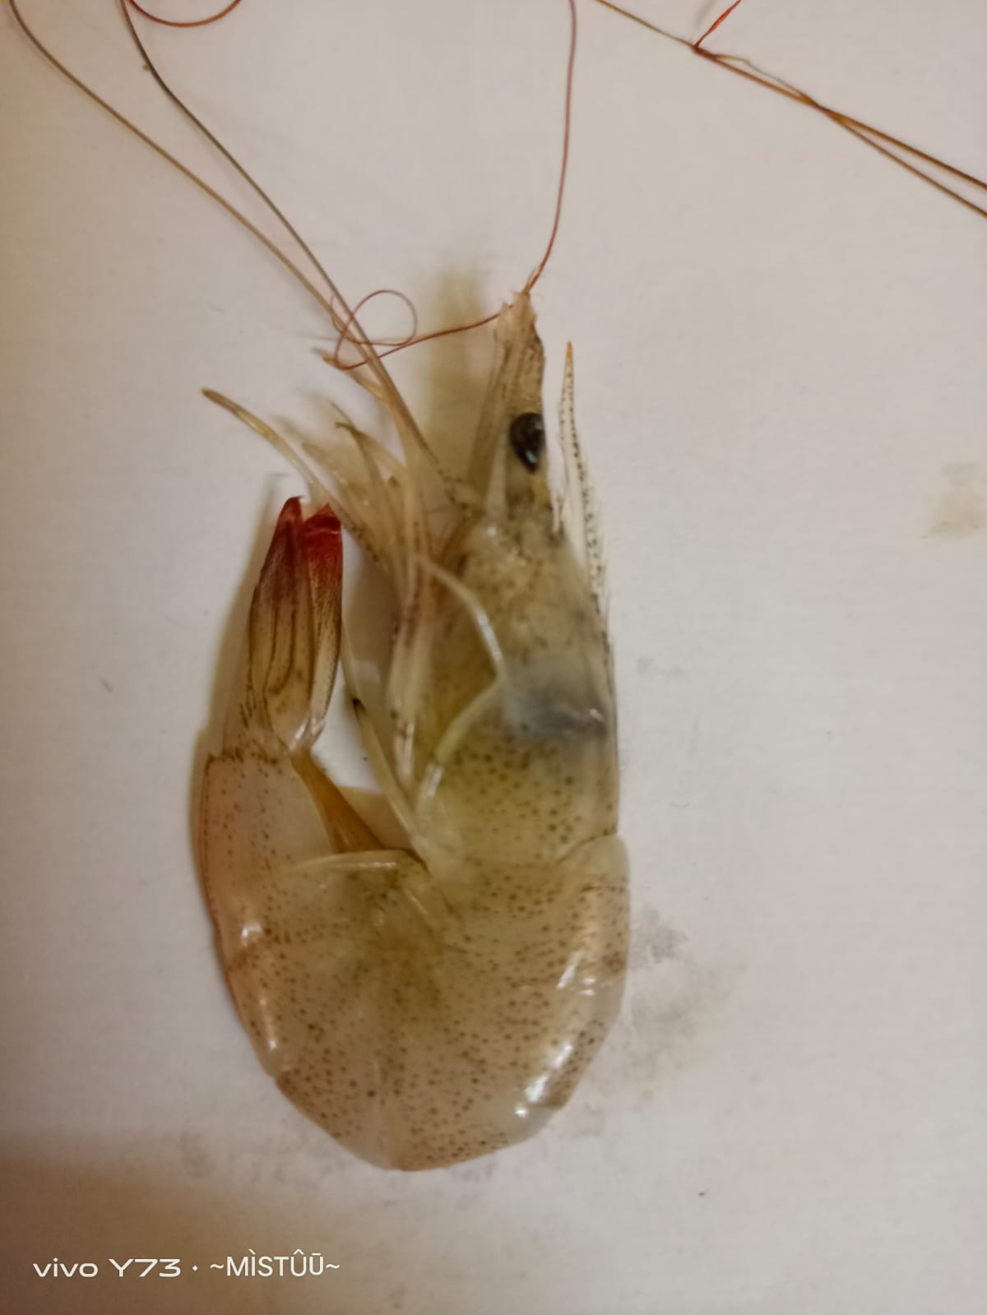 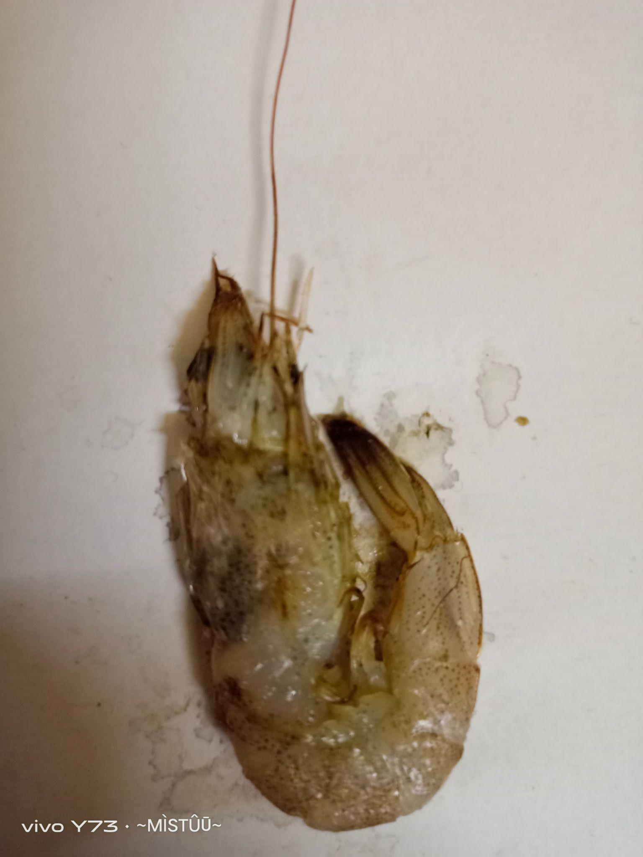

Fig. 1.3.1 Consumable Fig. 1.3.2 Non-Consumable

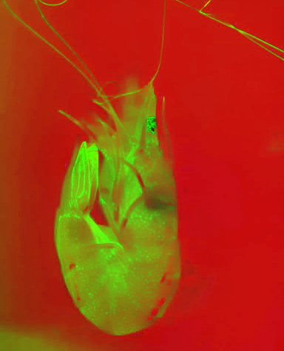 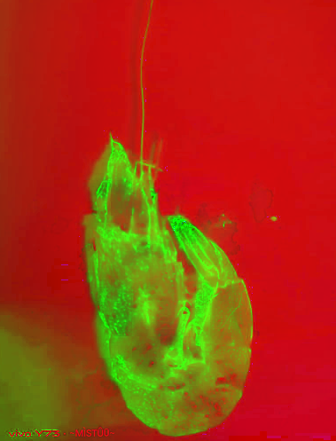

Fig. 1.3.3 Consumable (In HSV) Fig. 1.3.4 Non-Consumable (In HSV)

Machine Learning Methods

**1. Naive Bayes**

Naive Bayes classifiers are a family of simple "probabilistic classifiers" based on applying Bayes' theorem with strong (naive) independence assumptions between the features (see Bayes classifier). They are among the simplest Bayesian network models, but coupled with kernel density estimation, they can achieve high accuracy levels.

**Bayes Theorem:**

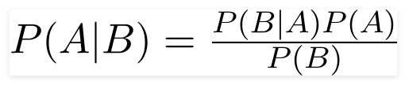

Fig. 2.1.0

Using Bayes theorem, we can find the probability of **A** happening, given that **B** has occurred (Refer Fig 2.1.0). Here, **B** is the evidence and **A** is the hypothesis. The assumption made here is that the predictors/features are independent. That is, the presence of one particular feature does not affect the other. Hence it is called naive.

The proposed system uses two color spaces (RGB and HSV) to train the model for each of the three dataset. After training the system the model classified each of the dataset into two classifications: consumable and non-consumable. The result of the test dataset for each of the dataset is shown in the figures below as a confusion matrix (Refer Fig. 2.1.1 to 2.1.6). [18]

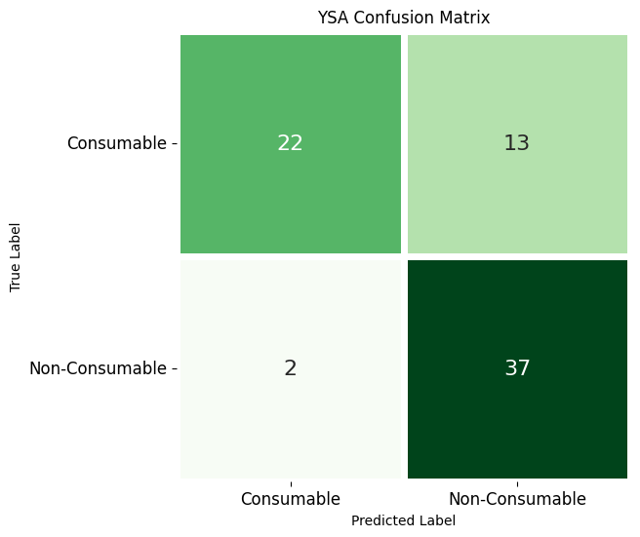 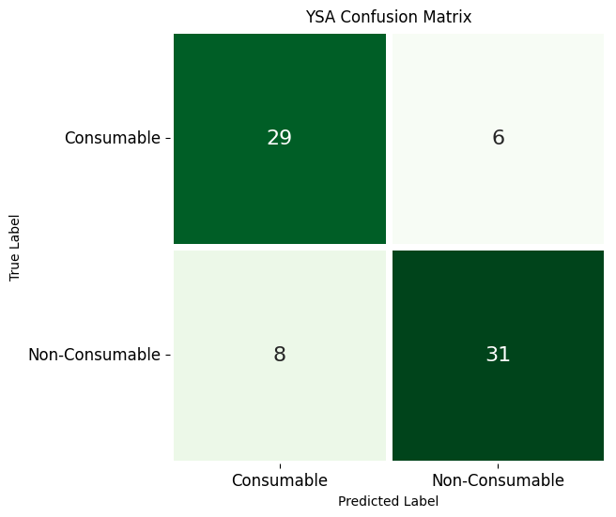

Fig. 2.1.1 Chicken Dataset (RGB) Fig. 2.1.2 Chicken Dataset (HSV)

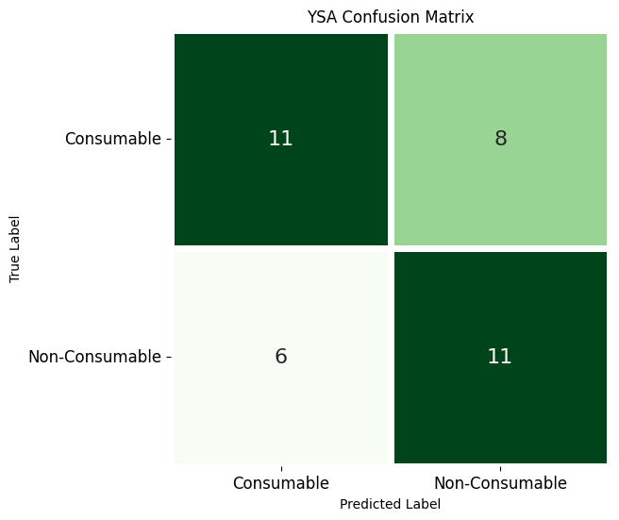 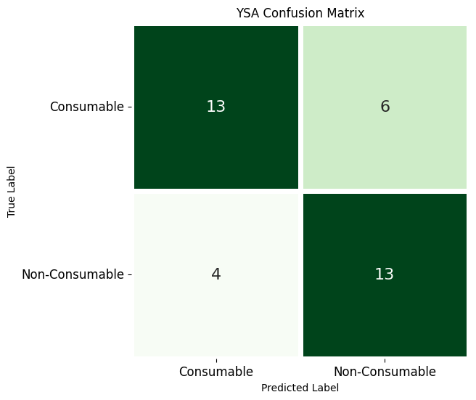

Fig. 2.1.3 Fish Dataset (RGB) Fig. 2.1.4 Fish Dataset (HSV)

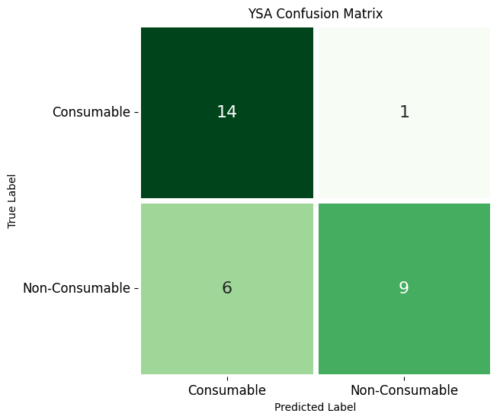 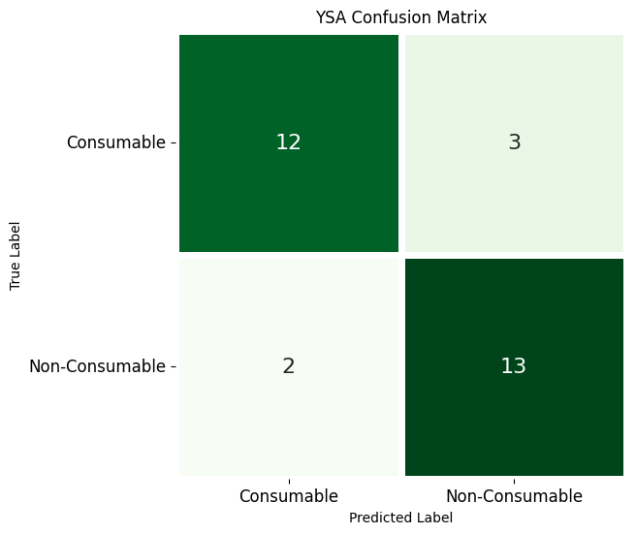

Fig. 2.1.5 Prawn Dataset (RGB) Fig. 2.1.6 Prawn Dataset (HSV)

As we can see Chicken (Refer Fig. 2.1.1 and 2.1.2) and Prawn (Refer Fig. 2.1.5 and 2.1.6) provided a better accuracy than Fish (Refer Fig. 2.1.3 and 2.1.4) in this model. Chicken in HSV Color Space (Refer Fig. 2.1.2) provided the best accuracy under this model.

**2. KNN**

In statistics, the ***k*-nearest neighbors algorithm** (***k*-NN**) is a non-parametric supervised learning method first developed by Evelyn Fix and Joseph Hodges in 1951, and later expanded by Thomas Cover. It is used for classification and regression. In both cases, the input consists of the *k* closest training examples in a data set. The output depends on whether *k*-NN is used for classification or regression:

* In *k-NN classification*, the output is a class membership. An object is classified by a plurality vote of its neighbors, with the object being assigned to the class most common among its *k* nearest neighbors (*k* is a positive integer, typically small). If *k* = 1, then the object is simply assigned to the class of that single nearest neighbor.
* In *k-NN regression*, the output is the property value for the object. This value is the average of the values of *k* nearest neighbors.

*k*-NN is a type of classification where the function is only approximated locally and all computation is deferred until function evaluation. Since this algorithm relies on distance for classification, if the features represent different physical units or come in vastly different scales then normalizing the training data can improve its accuracy dramatically.

Both for classification and regression, a useful technique can be to assign weights to the contributions of the neighbors, so that the nearer neighbors contribute more to the average than the more distant ones. For example, a common weighting scheme consists in giving each neighbor a weight of 1/*d*, where *d* is the distance to the neighbor.

The proposed system uses two color spaces (RGB and HSV) to train the model for each of the three dataset. After training the system the model classified each of the dataset into two classifications: consumable and non-consumable. The result of the test dataset for each of the dataset is shown in the figures below as a confusion matrix (Refer Fig. 2.2.1 to 2.2.6). [19]

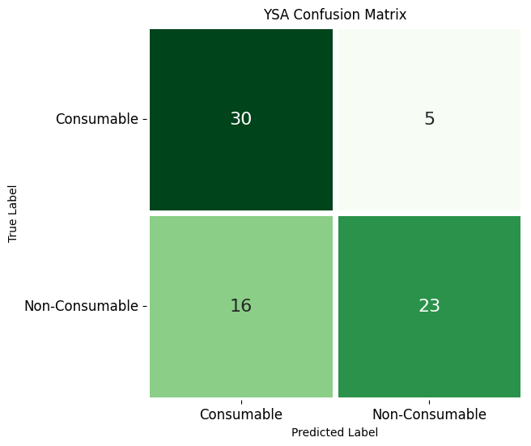 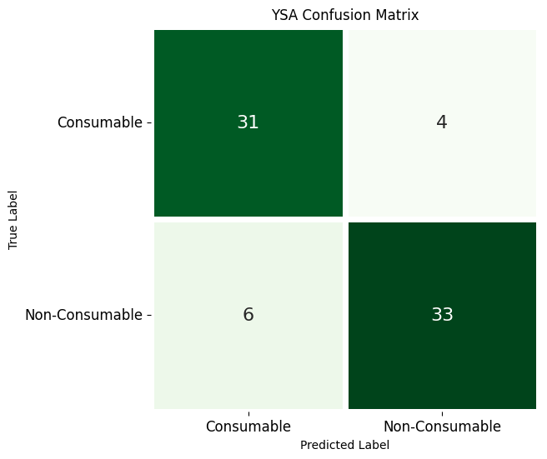

Fig. 2.2.1 Chicken Dataset (RGB) Fig. 2.2.2 Chicken Dataset (HSV)

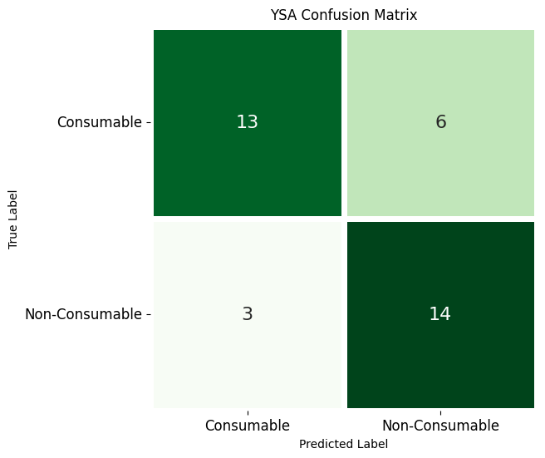 

Fig. 2.2.3 Fish Dataset (RGB) Fig. 2.2.4 Fish Dataset (HSV)

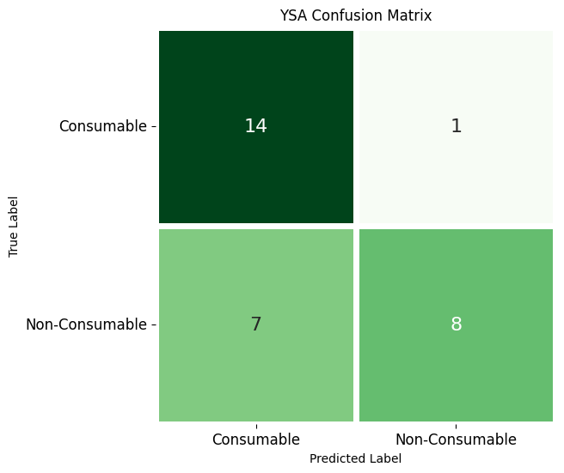 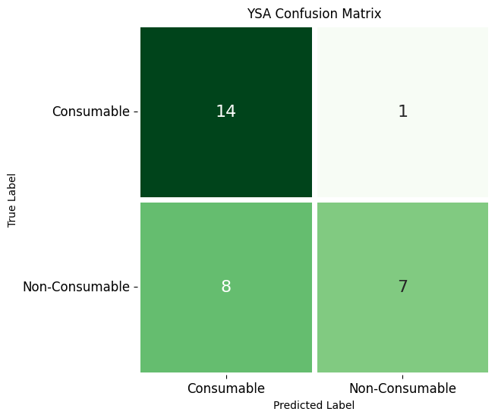

Fig. 2.2.5 Prawn Dataset (RGB) Fig. 2.2.6 Prawn Dataset (HSV)

As we can see all three datasets provide almost the same accuracy in RGB but in HSV color space Chicken (Refer Fig. 2.2.2) provides better results than the other two.

**3. SVM**

In machine learning, **support vector machines** (**SVMs**, also **support vector networks**) are supervised learning models with associated learning algorithms that analyze data for classification and regression analysis. Developed at AT&T Bell Laboratories by Vladimir Vapnik with colleagues (Boser et al., 1992, Guyon et al., 1993, Cortes and Vapnik, 1995, Vapnik et al., 1997) SVMs are one of the most robust prediction methods, being based on statistical learning frameworks or VC theory proposed by Vapnik (1982, 1995) and Chervonenkis (1974)[7]. Given a set of training examples, each marked as belonging to one of two categories, an SVM training algorithm builds a model that assigns new examples to one category or the other, making it a non-probabilistic binary linear classifier (although methods such as Platt scaling exist to use SVM in a probabilistic classification setting). SVM maps training examples to points in space so as to maximize the width of the gap between the two categories[7]. New examples are then mapped into that same space and predicted to belong to a category based on which side of the gap they fall. The proposed system uses two color spaces (RGB and HSV) to train the model for each of the three dataset. After training the system the model classified each of the dataset into two classifications : consumable and non-consumable. The result of the test dataset for each of the dataset is shown in the figures below as a confusion matrix (Refer Fig. 2.3.1 to 2.3.6). [20]

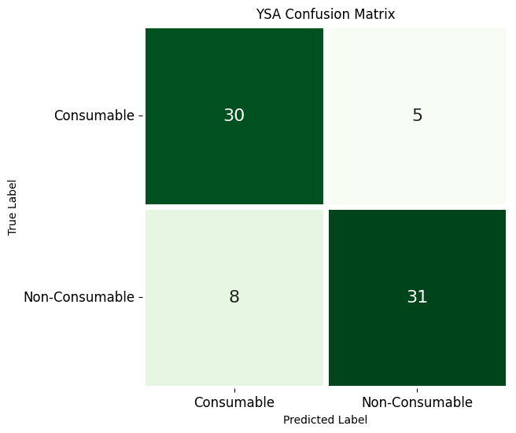 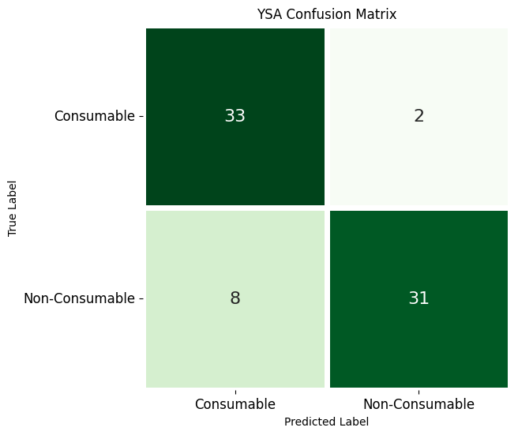

Fig. 2.3.1 Chicken Dataset (RGB) Fig. 2.3.2 Chicken Dataset (HSV)

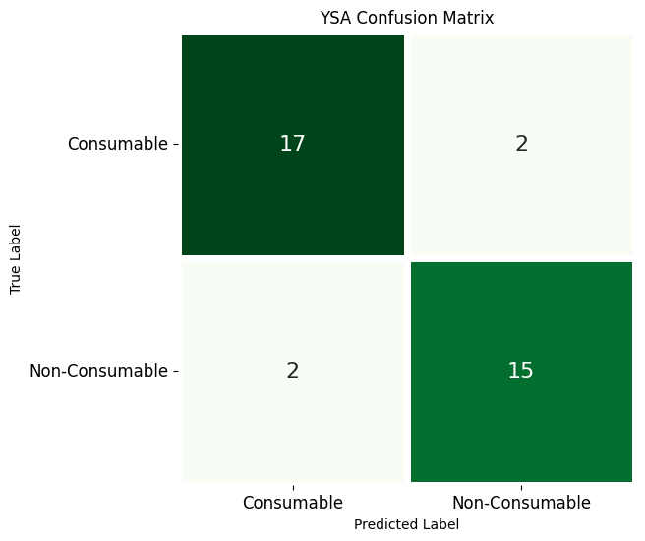 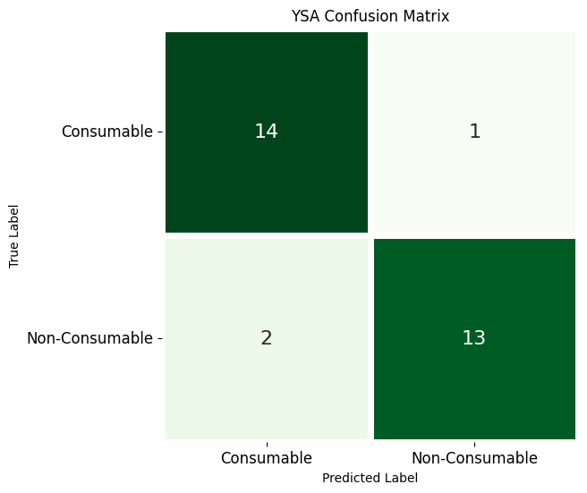

Fig. 2.3.3 Fish Dataset (RGB) Fig. 2.3.4 Fish Dataset (HSV)

 

Fig. 2.3.5 Prawn Dataset (RGB) Fig. 2.3.6 Prawn Dataset (HSV)

As we can see the datasets containing prawn provided excellent accuracy under this model in both color spaces (Refer Fig. 2.3.5 and 2.3.6). The other two datasets also provided good output in both color spaces.

**4. Random Forest**

Random forests or random decision forests is an ensemble learning method for classification, regression and other tasks that operates by constructing a multitude of decision trees at training time[8]. For classification tasks, the output of the random forest is the class selected by most trees. For regression tasks, the mean or average prediction of the individual trees is returned. Random decision forests correct for decision trees' habit of overfitting to their training set.  Random forests generally outperform decision trees, but their accuracy is lower than gradient boosted trees.[citation needed] However, data characteristics can affect their performance[8].

The proposed system uses two color spaces (RGB and HSV) to train the model for each of the three dataset. After training the system the model classified each of the dataset into two classifications : consumable and non-consumable. The result of the test dataset for each of the dataset is shown in the figures below as a confusion matrix (Refer Fig. 2.4.1 to 2.4.6). [21]

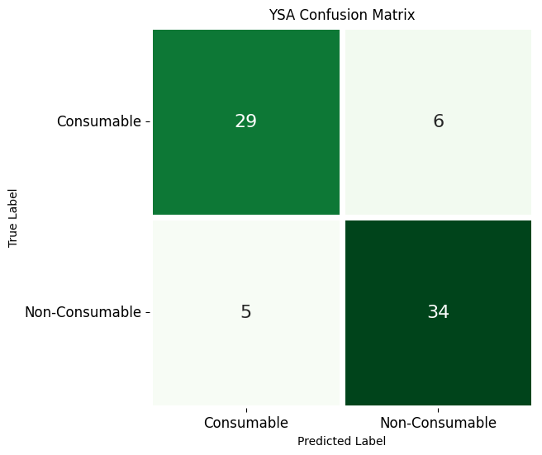 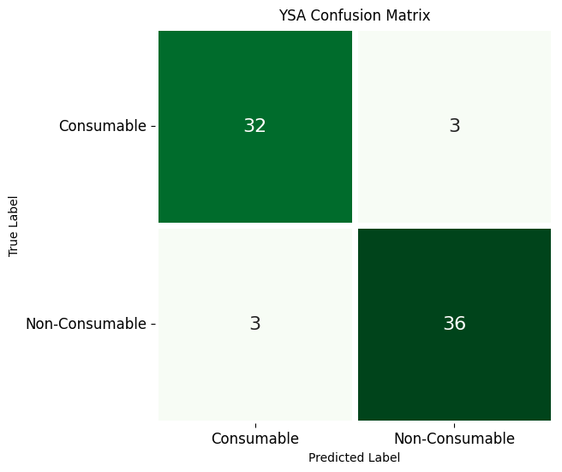

Fig. 2.4.1 Chicken Dataset (RGB) Fig. 2.4.2 Chicken Dataset (HSV)

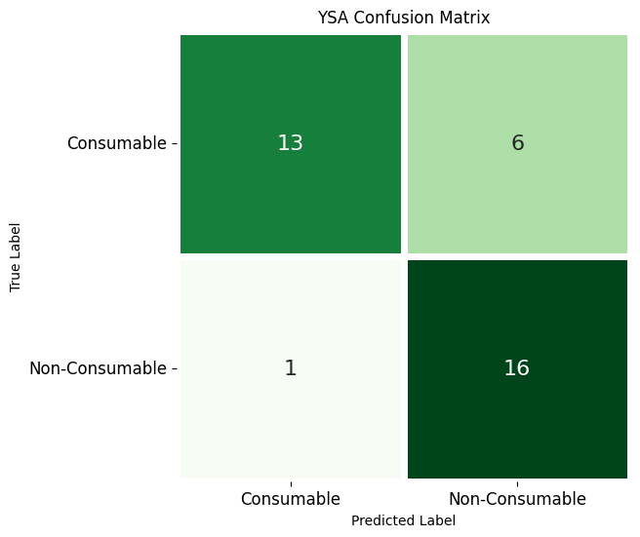 

Fig. 2.4.3 Fish Dataset (RGB) Fig. 2.4.4 Fish Dataset (HSV)

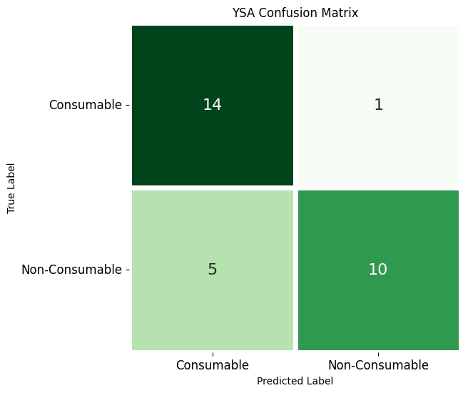 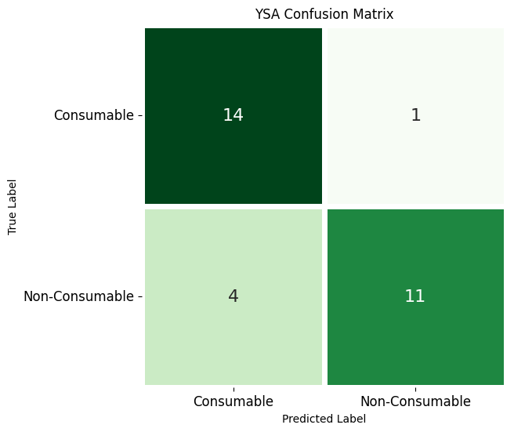

Fig. 2.4.5 Prawn Dataset (RGB) Fig. 2.4.6 Prawn Dataset (HSV)

As we can see Chicken and Fish equally provided good results under this method mainly in HSV color spaces (Refer Fig. 2.4.2 and 2.4.4). Prawn gave somewhat intermediate accuracy in HSV Color space (Refer Fig 2.4.6).

Machine Learning Results and Discussion

The experiment was to predict the freshness of meat on a given color space, and the results are the accuracies on the different dataset. The results show that image classification can be used to classify good (consumable) and bad (non-consumable) meat. One of the important results was quality of image and color space played a vital role in predicting the quality of meat. The results classified meat according to their freshness criteria. The biggest strength of the study was the model being simplistic, but limitations are less accurate compared to deep learning models, which are very complex. The variables were like, Random Forest being the best model for chicken classifier whereas for prawn the best was SVM.

The complete analysis is shown in table (Refer Table 2) below.

**Table 2: Accuracy observed for different models for different datasets under different color spaces.**

|  |  |  |  |  |
| --- | --- | --- | --- | --- |
| Classifier | Type of sample | Number of sample | Color space | Accuracy  (%) |
| Naive Bayes | CHICKEN | 310 | RGB | 79.729 |
| HSV | 89.081 |
| FISH | 140 | RGB | 61.111 |
| HSV | 72.222 |
| PRAWN | 122 | RGB | 76.666 |
| HSV | 83.333 |
| KNN | CHICKEN | 310 | RGB | 71.621 |
| HSV | 86.486 |
| FISH | 140 | RGB | 72.012 |
| HSV | 75.023 |
| PRAWN | 122 | RGB | 73.333 |
| HSV | 70 |
| SVM | CHICKEN | 310 | RGB | 82.432 |
| HSV | 86.486 |
| FISH | 140 | RGB | 88.888 |
| HSV | 88.888 |
| PRAWN | 122 | RGB | 90 |
| HSV | 90 |
| Random Forest | CHICKEN | 310 | RGB | 85.135 |
| HSV | 91.891 |
| FISH | 140 | RGB | 80.555 |
| HSV | 88.888 |
| PRAWN | 122 | RGB | 80 |
| HSV | 83.333 |

* Taken by average from multiple results by randomizing the dataset.

When working with Chicken dataset in both the color spaces, we have observed that in all the algorithms HSV color space provided much better results than its RGB counterpart (Refer Fig 3.1). Out of all the algorithms Random Forest showed the best accuracy in both color spaces.

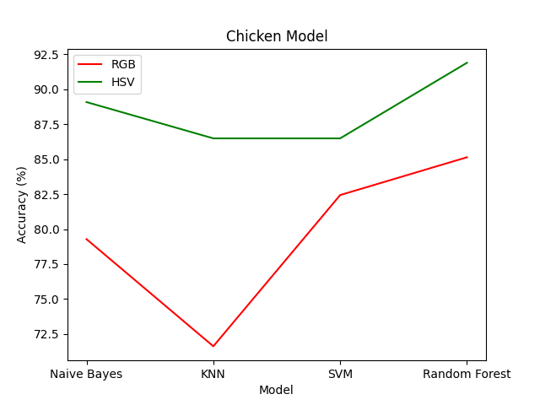

Fig. 3.1 Chicken dataset

When working with Fish dataset in both the color spaces, we have observed that in all the algorithms HSV color space provided slightly better results than its RGB counterpart (Refer Fig 3.2). Out of all the algorithms Random Forest and SVM showed the best accuracy in HSV color space.

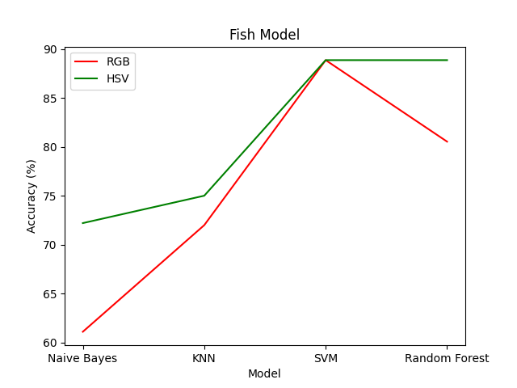

Fig. 3.2 Fish dataset

When working with Prawn dataset in both the color spaces, we have observed that in most of the algorithms in HSV and RGB color spaces provided almost the same accuracy (Refer Fig 3.3). Out of all the algorithms SVM showed the best accuracy in both color spaces.

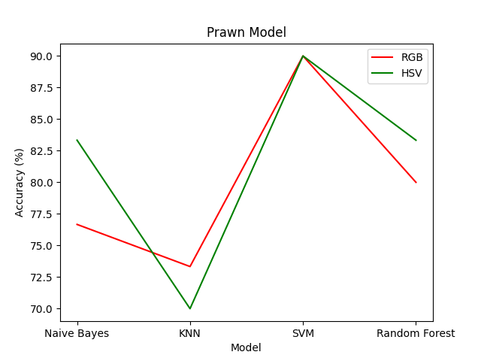

Fig 3.3 Prawn dataset

Deep Learning Methods

**1. Convolutional Neural Network**

A convolutional neural network (CNN) is a type of artificial neural network that can process images and other types of data with spatial structure. A CNN consists of one or more convolutional layers, followed by optional pooling layers, activation functions, and fully connected layers. A convolutional layer applies a set of filters to the input data, producing a feature map that captures the local patterns in the data. A pooling layer reduces the size of the feature map by applying a function such as a max or average over a small region. An activation function introduces non-linearity to the network, allowing it to learn complex functions. A fully connected layer connects every neuron in one layer to every neuron in the next layer, forming the output of the network. CNNs are widely used for tasks such as image classification, object detection, face recognition, natural language processing, and more. [22]

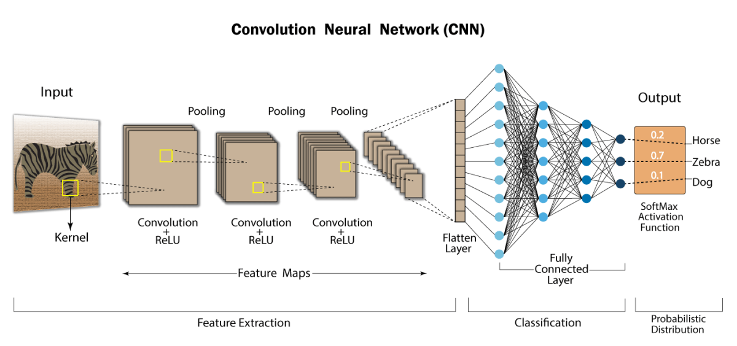

Fig 4.1.1 Image explaining how a CNN model works

To train our model, we used the three different datasets of chicken, fish, and prawn, each with several hundred images. We first preprocessed the images, converting them from RGB to HSV colour space to better capture the colour and luminance information in the images. We then trained our model on these preprocessed images, using the Sequential model in Keras on top of TensorFlow.

In Keras, a Sequential model is a linear stack of layers, where you can simply add layers one after another to form a neural network. It is a way to create deep learning models that allows you to easily build neural networks without worrying too much about the complexity of the underlying architecture.

The model was trained to classify the meat images into two categories, Consumable and Non-Consumable, based on their quality. Our results showed that the model was able to accurately classify the images with an average accuracy on HSV colour space of over 85%.

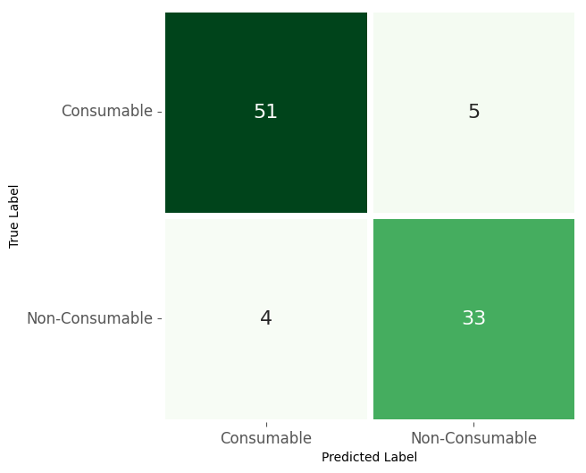 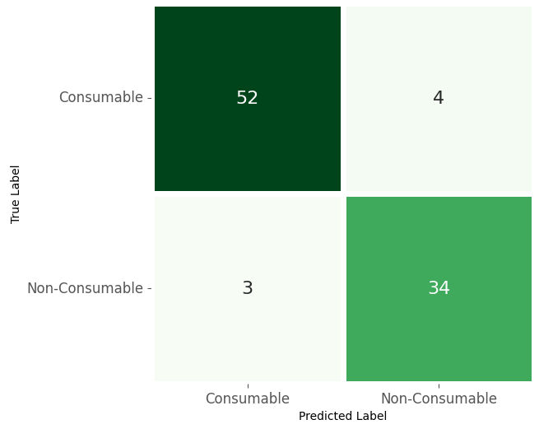

Fig. 4.1.2 Chicken Dataset (RGB) Fig. 4.1.3 Chicken Dataset (HSV)

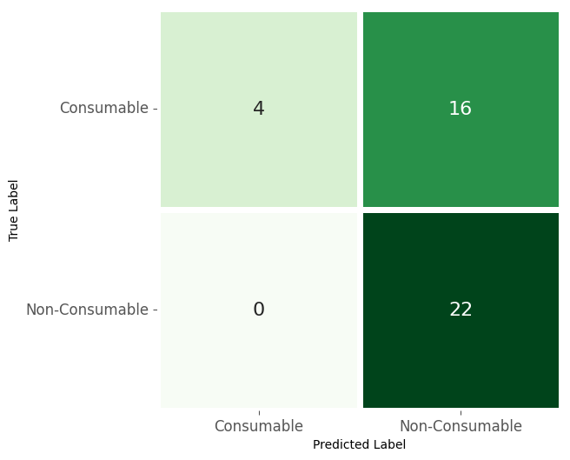 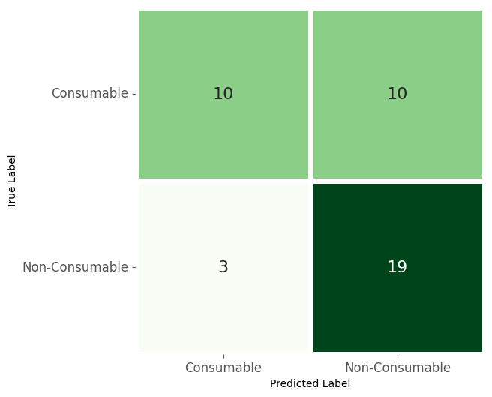

Fig.4.1.4 Fish Dataset (RGB) Fig. 4.1.5 Fish Dataset (HSV)

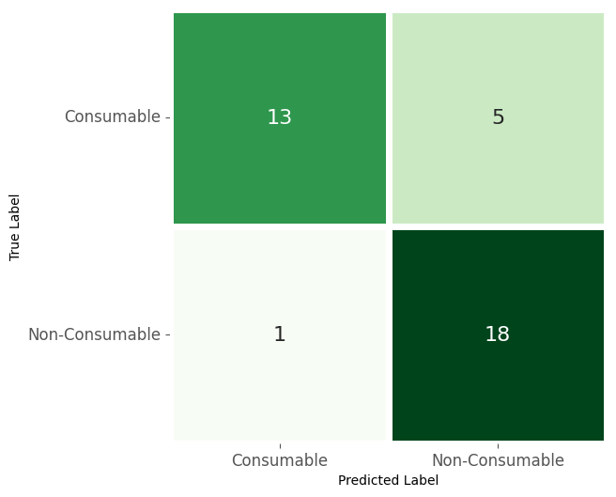 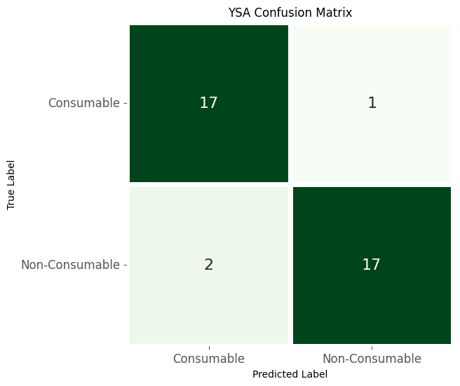

Fig. 4.1.6 Prawn Dataset (RGB) Fig. 4.1.7 Prawn Dataset (HSV)

**2. ResNet**

ResNet (Residual Network) is another popular deep learning architecture introduced by He et al. in 2015. It addresses the problem of vanishing gradients in very deep neural networks by introducing skip connections, or shortcuts, that allow gradients to flow more easily through the network.

In a ResNet, residual blocks are used to learn residual functions that can be added to the output of a previous layer, bypassing one or more layers in the network. This allows the network to learn the difference between the input and the desired output, instead of trying to learn the entire mapping from scratch. As a result, ResNets are able to train much deeper networks, with up to hundreds or even thousands of layers. [23]

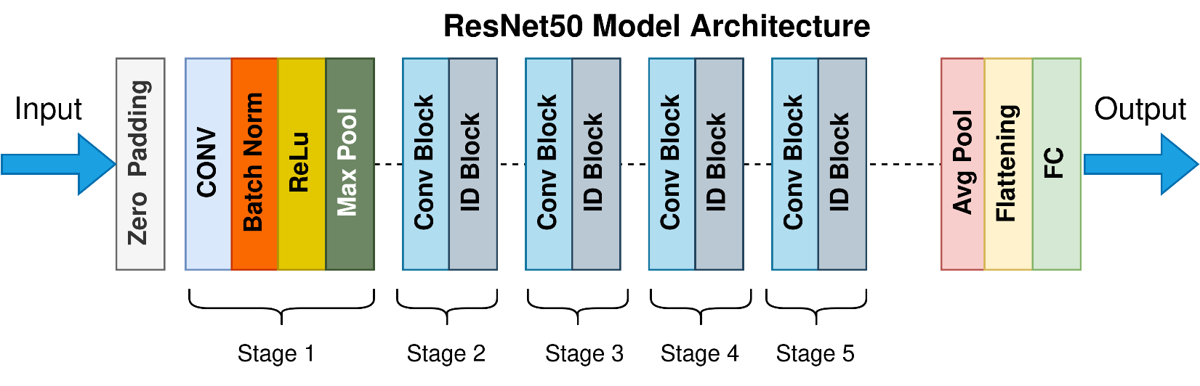

Fig 4.2.1 Image explaining how a CNN model works

ResNets have achieved state-of-the-art performance on a wide range of computer vision tasks, including image classification, object detection, and semantic segmentation. They are also widely used in other fields, such as natural language processing and speech recognition.

 

Fig. 4.2.2 Chicken Dataset (RGB) Fig. 4.2.3 Chicken Dataset (HSV)

 

Fig. 4.2.4 Fish Dataset (RGB) Fig. 4.2.5 Fish Dataset (HSV)

 

Fig. 4.2.6 Prawn Dataset (RGB) Fig. 4.2.7 Prawn Dataset (HSV)

**3. DenseNet**

DenseNet (Dense Convolutional Network) is a deep learning architecture that has gained popularity in recent years for its ability to effectively handle feature reuse and feature propagation in deep neural networks. It was introduced in 2017 by Huang et al.

In a DenseNet, each layer receives inputs from all previous layers and passes its own output to all subsequent layers. This results in a dense connectivity pattern where each layer is connected to every other layer in a feed-forward fashion. This dense connectivity enables feature reuse and allows the network to extract more diverse and informative features, leading to better performance and reduced overfitting. [24]

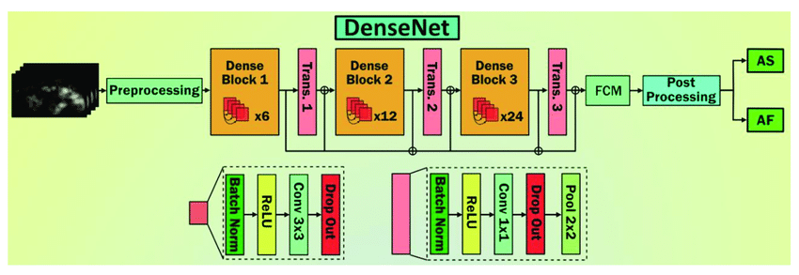

Fig 4.3.1 Image explaining how a DenseNet model works

DenseNets have been shown to outperform other state-of-the-art models on a range of image classification tasks, while requiring fewer parameters and less computation time. In addition, they have been successfully applied to other computer vision tasks such as object detection and semantic segmentation.

 

Fig. 4.3.2 Chicken Dataset (RGB) Fig. 4.3.3 Chicken Dataset (HSV)

 

Fig. 4.3.4 Fish Dataset (RGB) Fig. 4.3.5 Fish Dataset (HSV)



Fig. 4.3.6 Prawn Dataset (RGB) Fig. 4.3.7 Prawn Dataset (HSV)

Deep Learning Results and Discussion

The experiment was to predict the freshness of meat on a given color space, and the results are the accuracies on the different dataset. The results show that image classification can be used to classify good (consumable) and bad (non-consumable) meat. One of the important results was quality of image and color space played a vital role in predicting the quality of meat. The results classified meat according to their freshness criteria.

**Table 3: Accuracy observed for different models for different datasets under different colour spaces.**

|  |  |  |  |  |
| --- | --- | --- | --- | --- |
| Classifier | Type of sample | Number of sample | Color space | Accuracy  (%) |
| CNN | CHICKEN | 310 | RGB | 90.32 |
| HSV | 92.47 |
| FISH | 140 | RGB | 61.90 |
| HSV | 69.04 |
| PRAWN | 122 | RGB | 81.05 |
| HSV | 91.89 |
| ResNet | CHICKEN | 310 | RGB | 64.52 |
| HSV | 87.10 |
| FISH | 140 | RGB | 61.90 |
| HSV | 88.10 |
| PRAWN | 122 | RGB | 51.35 |
| HSV | 89.19 |
| DenseNet | CHICKEN | 310 | RGB | 63.44 |
| HSV | 88.17 |
| FISH | 140 | RGB | 52.38 |
| HSV | 57.14 |
| PRAWN | 122 | RGB | 48.65 |
| HSV | 94.59 |

* Taken by average from multiple results by randomizing the dataset.

When working with Chicken dataset in both the color spaces, we have observed that in all the algorithms HSV color space provided much better results than its RGB counterpart (Refer Fig 5.1). Out of all the algorithms CNN showed the best accuracy in both color spaces.

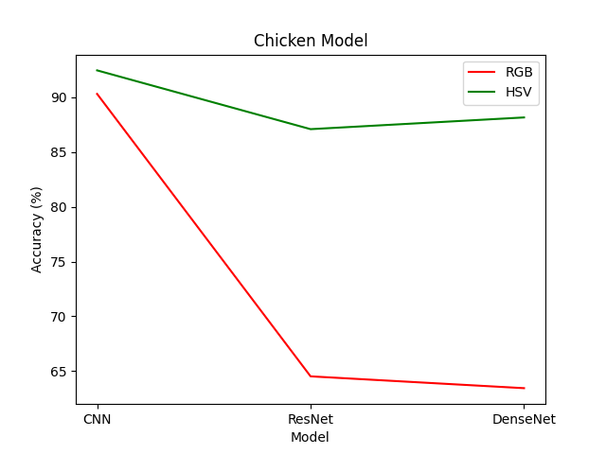

Fig. 5.1 Chicken dataset

When working with Fish dataset in both the color spaces, we have observed that in all the algorithms HSV color space provided slightly better results than its RGB counterpart (Refer Fig 5.2). Out of all the algorithms ResNet showed the best accuracy in HSV color space.

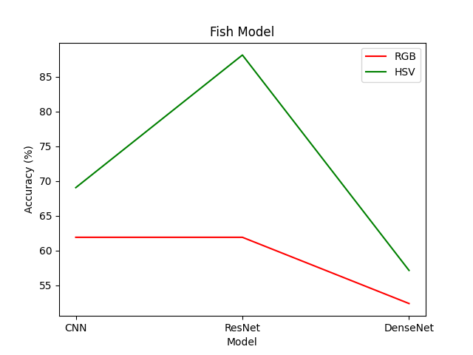

Fig. 5.2 Fish dataset

When working with Prawn dataset in both the colour spaces, we have observed that in all the algorithms HSV colour space provided slightly better results than its RGB counterpart (Refer Fig 5.3). Out of all the algorithms, CNN showed the best accuracy in both colour spaces.

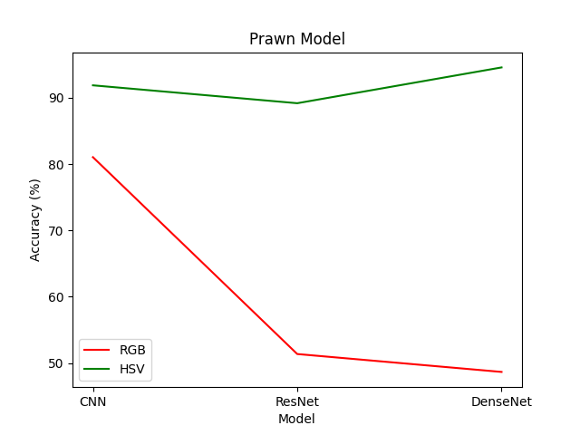

Fig 5.3 Prawn dataset

App Development

In this research, we developed a mobile application using Flutter, which integrates a converted TensorFlow Lite (TFLite) model of a Convolutional Neural Network (CNN) we developed earlier using the Keras interface of the TensorFlow framework. The purpose of this application is to classify three types of meat, namely chicken, prawn, and fish, and predict whether the meat is consumable or non-consumable.

Keras is a high-level interface for TensorFlow, a popular deep-learning framework. Keras simplifies the process of building and training neural networks by providing common layers, models, optimizers, and metrics. Keras also supports multiple backends, such as TensorFlow, Theano, and CNTK. To convert a TensorFlow model to TensorFlow Lite, you need to use the TensorFlow Lite Converter. The converter can take a SavedModel, a Keras model, or a concrete function as input and produce a TensorFlow Lite FlatBuffer file (.tflite) as output. The FlatBuffer file can then be deployed to mobile devices or embedded systems that support TensorFlow Lite. You can use the converter either as a Python API or as a command-line tool.

The application allows the user to input an image through either the gallery or camera functionality. Once the image is input, the TFLite model is used to predict the type of meat and its consumability. Additionally, the application provides a remarks section based on the percentage of consumability predicted by the model.

The application is not only easy to use but also designed to work both online and offline, making it convenient for users who may have limited access to the internet. This feature is particularly useful for users in areas with poor internet connectivity.

This application has the potential to be a useful tool in ensuring food safety by allowing users to quickly and easily determine the consumability of meat products.

 

Fig. 6.1 Home Page Fig. 6.2 Image Source Option

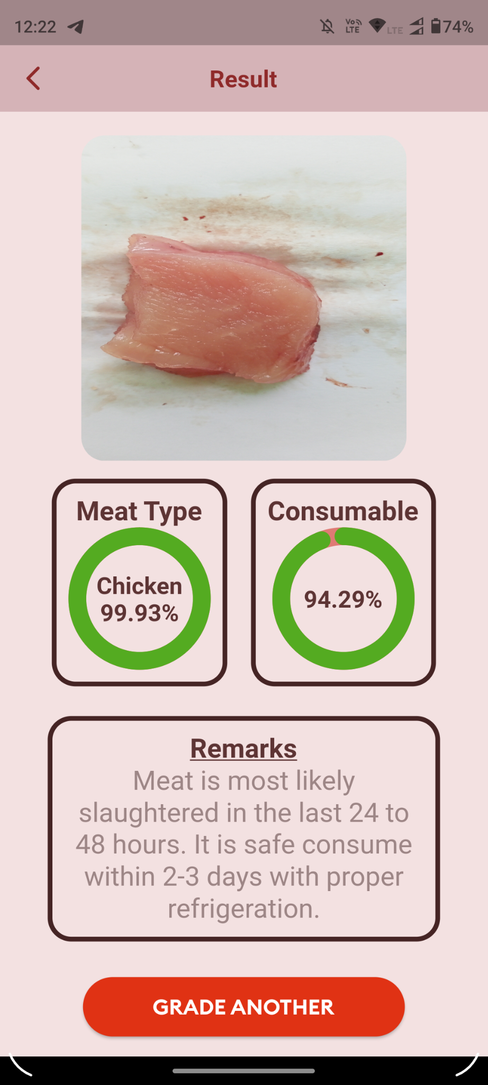 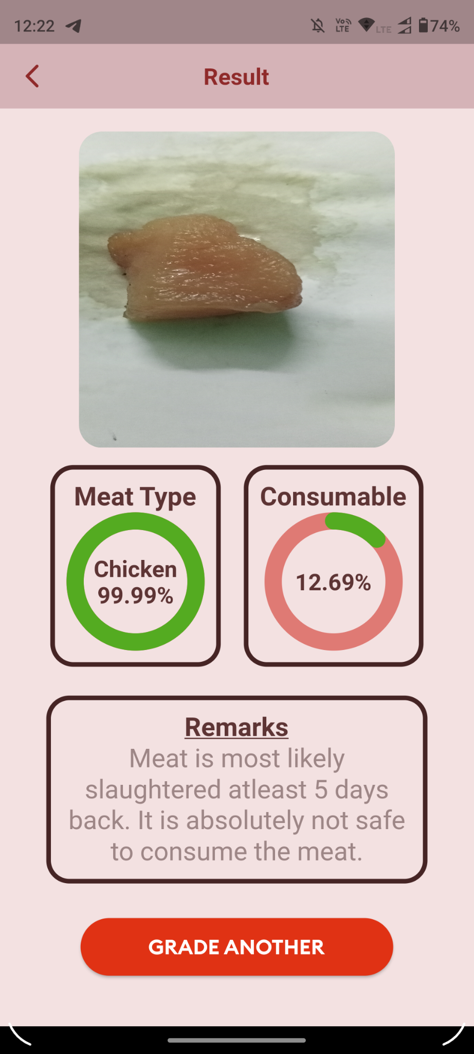

Fig. 6.3 Consumable Chicken Fig. 6.4 Non-Consumable Chicken

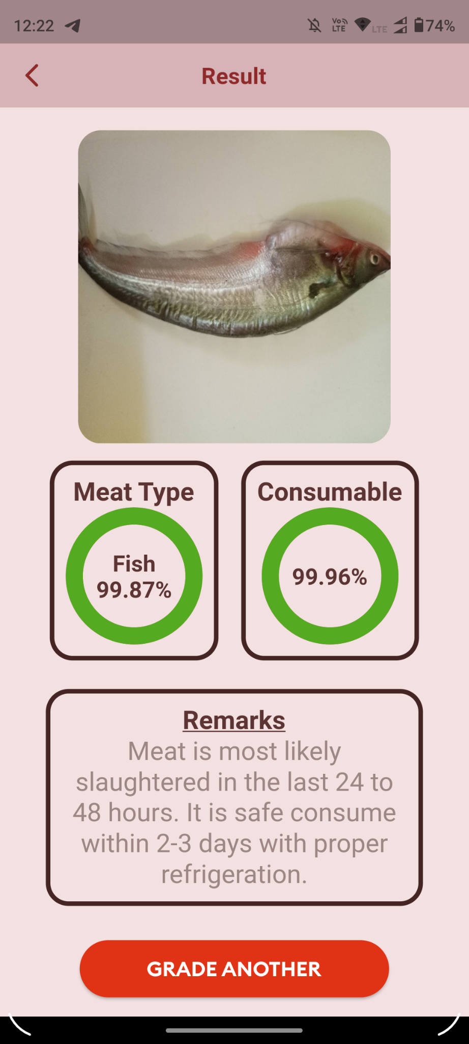 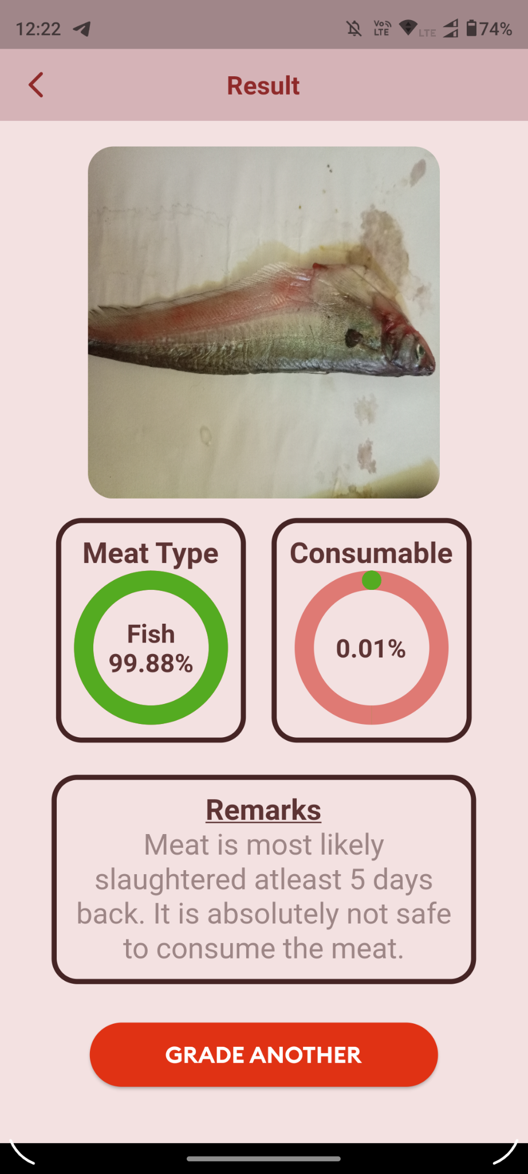

Fig. 6.5 Consumable Fish Fig. 6.6 Non-Consumable Fish

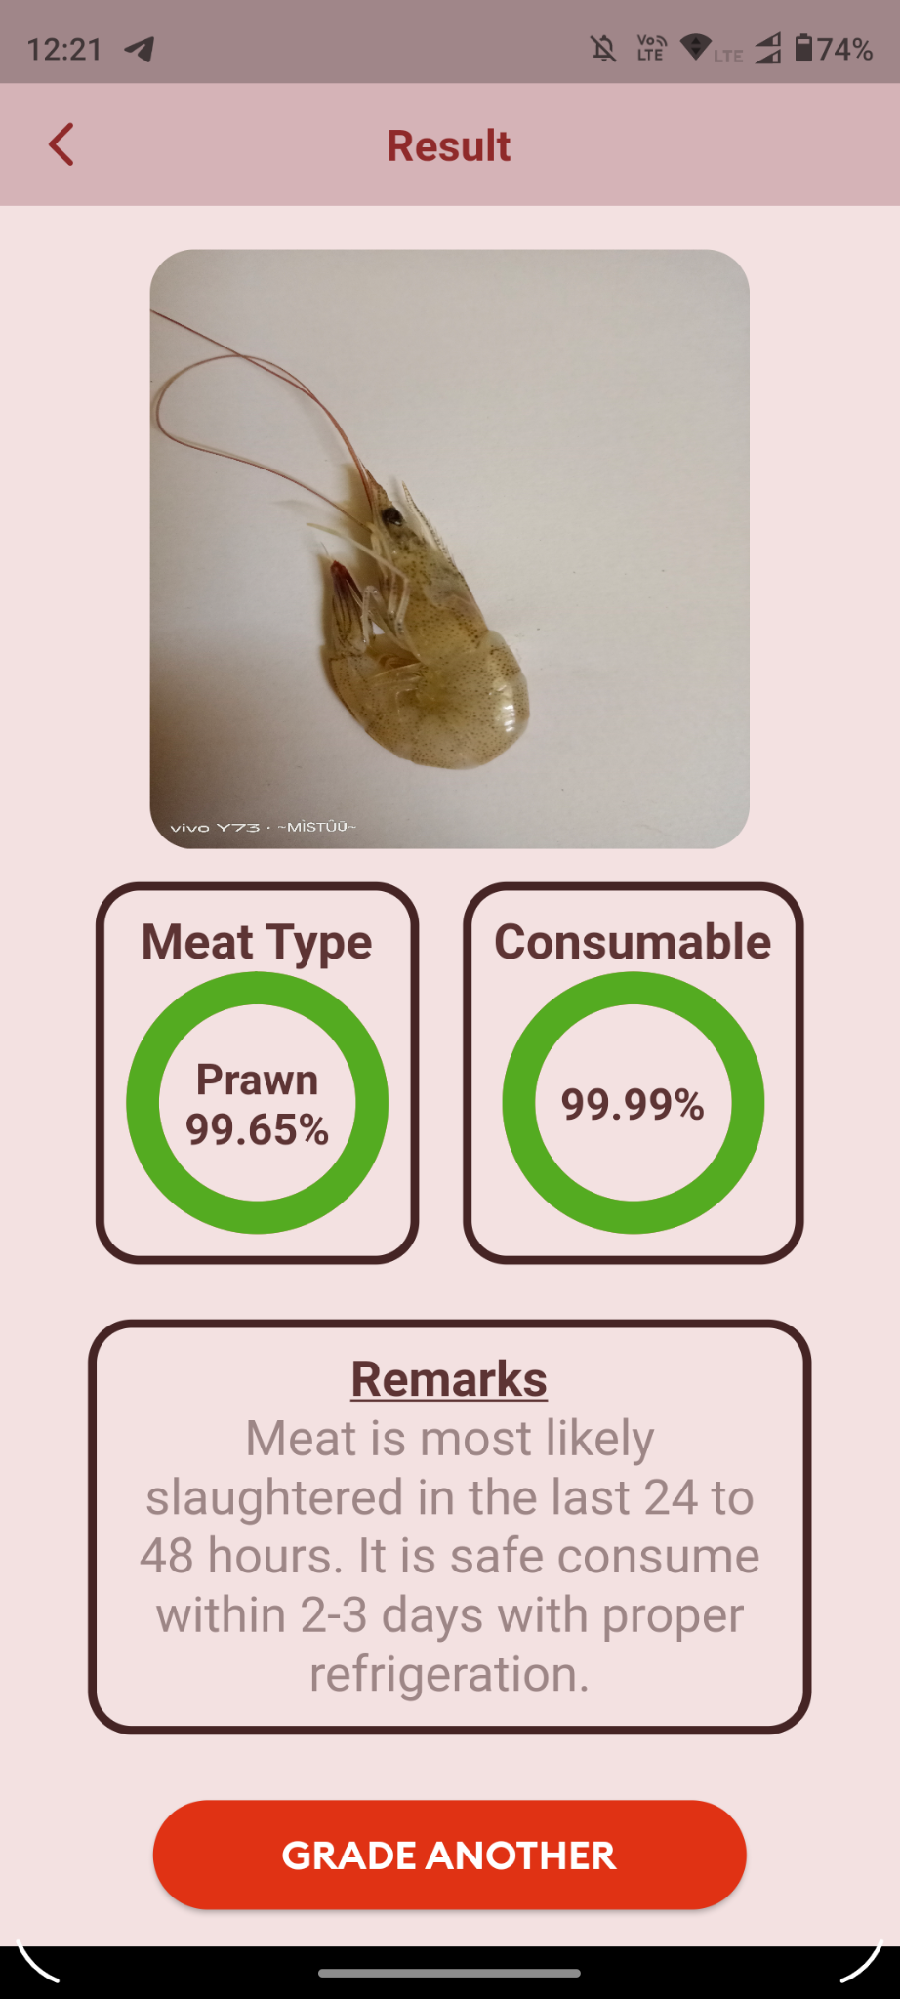 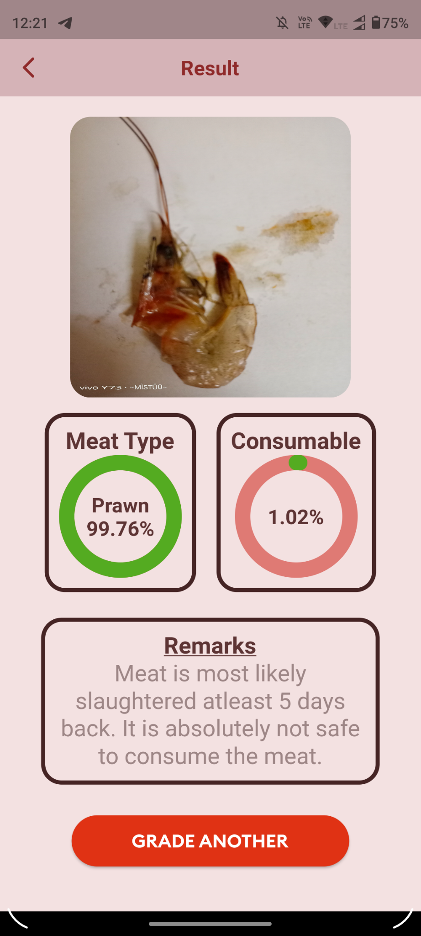

Fig. 6.7 Consumable Prawn Fig. 6.8 Non-Consumable Prawn

In our image classification app, we used images that were captured on a white background to train our model. This was done to ensure that the model was able to focus solely on the meat in the image, without being distracted or influenced by other elements in the environment.

However, it is important to note that the results produced by the model may differ if the images were taken on a colored background instead. This is because the color of the background could potentially interfere with the color and texture of the meat, which could in turn affect the accuracy of the predictions.

For example, if the meat were placed on a red background, the color of the background could reflect onto the meat, making it appear redder than it actually is. This could lead to misclassification of the meat, especially if the color of the meat is an important factor in determining its type or consumability.

Therefore, it is important to keep in mind the background used when taking images for classification purposes. Capturing images on a consistent background that does not interfere with the color and texture of the meat is crucial for ensuring accurate predictions.

Conclusion

Machine learning models used for the above problem for each of the dataset some particular models provided better accuracy than the others. For example, the Chicken dataset in HSV Color Space and in the Random Forest model provided a maximum accuracy which is over 90% whereas Prawn and Fish in both RGB and HSV colour space provided maximum accuracy of over 85% on the SVM Model.

When dealing with large datasets, traditional machine learning algorithms may not be able to provide satisfactory accuracy. In such cases, deep learning models like CNNs, ResNets, and DenseNets are often employed to achieve better performance. After experimenting with these models, it was found that the CNN model performed the best, providing an overall accuracy of 85%. Therefore, this model was selected as the base.

It is important to note that deep learning models are particularly effective for image-related tasks, such as object recognition and classification, due to their ability to automatically learn complex features and patterns from large datasets. This is achieved through the use of multiple layers of interconnected neurons that can extract and process information from the input data in a hierarchical manner. Overall, the use of deep learning models has revolutionized the field of machine learning, allowing us to tackle increasingly complex problems and achieve unprecedented levels of accuracy.

Accurate meat freshness assessment is crucial for the problem of food quality. In general, meat freshness cannot be assessed accurately by any single conventional index because every index reflects only partial characteristics of a meat sample. To conclude, artificial vision and machine learning is a reliable technique, and it has shown its efficiency in many applications related to meat assessment.

The images used in this study were captured on a white background. However, it is possible that the results could differ if images were taken on a colored background instead. This is because the color of the background could potentially interfere with the color and texture of the meat, which could in turn affect the accuracy of the predictions.

Future Work

In our project, we developed a mobile app which uses a convolutional neural network (CNN) model to predict the quality of meat. However, there is always room for improvement in any project, and we have identified several potential areas for future work.

One area for improvement is the exploration of more complex deep learning models that can be efficiently incorporated into low-end devices such as mobile phones or Raspberry Pi's. While we were able to successfully develop and implement our CNN model, we were limited in our ability to try more complex models due to the device's system limitations. By exploring other deep learning models, we may be able to improve the accuracy of our meat quality predictions.

Another potential area for improvement is making the app connected to the cloud. By doing this, we could incorporate reinforcement learning into the app, which would allow it to rectify its output and improve the learning model based on user feedback. This approach would enable the app to continuously improve its accuracy and better meet the needs of its users.

Another area where we could make improvements is in the model that predicts the type of meat before predicting the quality of the meat. While this model is effective in most cases, it is not always accurate and can sometimes incorrectly identify certain objects as a specific type of meat. To address this issue, we could explore ways to improve the meat-type prediction model, such as by using more advanced image recognition algorithms or by incorporating other relevant data into the model.

In addition to these technical improvements, there are also several other areas where we could further develop the app. For example, we could enhance the user interface to make it more user-friendly and intuitive. We could also incorporate additional features such as nutritional information and recipe suggestions based on the type and quality of the meat.

Overall, while we are proud of the work we have done so far, we recognize that there is always room for improvement. By continuing to explore new deep learning models, incorporating reinforcement learning, and improving the meat type prediction model, we can make our app more effective and useful for its users. Additionally, by enhancing the user interface and incorporating new features, we can make the app even more user-friendly and valuable. Ultimately, our goal is to provide a high-quality, easy-to-use tool that helps consumers make informed decisions about the meat they consume.

References

*[1] Wijaya, Dedy Rahman, Riyanarto Sarno, and Enny Zulaika. "Noise filtering framework for electronic nose signals: An application for beef quality monitoring." Computers and Electronics in Agriculture 157 (2019): 305-321.*

*[2] Falasconi M, Concina I, Gobbi E, Sberveglieri V, Pulvirenti A, Sberveglieri. G.Electronic Nose for Microbiological Quality Control of Food Products. 2012; 2012.*

*[3] Makanan BPO. Graph of national poisoning case. , Jakarta (2016).*

*[4] https://www.fao.org/news/story/en/item/35571/icode/*

*[5] Trientin, Danika, Bambang Hidayat, and Sjafril Darana. "Beef freshness classification by using color analysis, multi-wavelet transformation, and artificial neural network." 2015 International Conference on Automation, Cognitive Science, Optics, Micro Electro-Mechanical System, and Information Technology (ICACOMIT). IEEE, 2015.*

*[6] Taheri-Garavand, Amin, et al. "Real-time nondestructive monitoring of Common Carp Fish freshness using robust vision-based intelligent modeling approaches." Computers and Electronics in Agriculture 159 (2019): 16-27.*

*[7] Agustin, S., and R. Dijaya. "Beef image classification using K-nearest neighbor algorithm for identification quality and freshness." Journal of Physics: Conference Series. Vol. 1179. No. 1. IOP Publishing, 2019.*

*[8] Lumogdang, Christell Faith D., et al. "Supervised Machine Learning Approach for Pork Meat Freshness Identification." Proceedings of the 2019 6th International Conference on Bioinformatics Research and Applications. 2019.*

*[9] Lugatiman, Kenan, et al. "Tuna meat freshness classification through computer vision." 2019 IEEE 11th International Conference on Humanoid, Nanotechnology, Information Technology, Communication and Control, Environment, and Management (HNICEM). IEEE, 2019.*

*[10] Sun, Xin, et al. "Predicting pork color scores using computer vision and support vector machine technology." Meat and Muscle Biology 2.1 (2018).*

*[11] Hebbar, Nachiketa. "Freshness of food detection using IoT and machine learning." 2020 International Conference on Emerging Trends in Information Technology and Engineering (ic-ETITE). IEEE, 2020.*

*[12] Guan, Xiao, et al. "Assessing the freshness of meat by using quantum-behaved particle swarm optimization and support vector machine." Journal of food protection 76.11 (2013): 1916-1922.*

*[13] Arsalane, Assia, et al. "An embedded system based on DSP platform and PCA-SVM algorithms for rapid beef meat freshness prediction and identification." Computers and Electronics in Agriculture 152 (2018): 385-392.*

*[14] Taheri-Garavand, Amin, et al. "Real-time nondestructive monitoring of Common Carp Fish freshness using robust vision-based intelligent modeling approaches." Computers and Electronics in Agriculture 159 (2019): 16-27.*

*[15] Dutta, Malay Kishore, et al. "Image processing based method to assess fish quality and freshness." Journal of Food Engineering 177 (2016): 50-58.*

*[16] Winiarti, Sri, Ahmad Azhari, and Khalidia Mega Agusta. "Determining feasibility level of beef quality based on histogram and k-means clustering." 2018 International Symposium on Advanced Intelligent Informatics (SAIN). IEEE, 2018.*

*[17] Chernov, Vladimir, Jarmo Alander, and Vladimir Bochko. "Integer-based accurate conversion between RGB and HSV color spaces." Computers & Electrical Engineering 46 (2015): 328-337.*

*[18] Wijaya, Dedy Rahman, Riyanarto Sarno, and Aldhiaz Fathra Daiva. "Electronic nose for classifying beef and pork using Naïve Bayes." 2017 International Seminar on Sensors, Instrumentation, Measurement and Metrology (ISSIMM). IEEE, 2017.*

*[19] Adi, Kusworo, et al. "Beef quality identification using color analysis and k-nearest neighbor classification." 2015 4th International Conference on Instrumentation, Communications, Information Technology, and Biomedical Engineering (ICICI-BME). IEEE, 2015.*

*[20] Cortez, Paulo, et al. "Lamb meat quality assessment by support vector machines." Neural Processing Letters 24 (2006): 41-51.*

*[21] Hanif, Salman, Dedy Rahman Wijaya, and Pramuko Aji. "Random Forest Algorithm for Meat Classification and Microbial Population Prediction." 2022 5th International Conference on Information and Communications Technology (ICOIACT). IEEE, 2022.*

*[22] Tan, Wei Keong, Zulkifli Husin, and Muhammad Amir Hakim Ismail. "Feasibility study of beef quality assessment using computer vision and Deep Neural Network (DNN) algorithm." 2020 8th International Conference on Information Technology and Multimedia (ICIMU). IEEE, 2020.*

*[23] Arora, Monika, and Parthasarathi Mangipudi. "A computer vision-based method for classification of red meat quality after nitrosamine appendage." International Journal of Computational Intelligence and Applications 20.01 (2021): 2150005.*

*[24] Lu, Tao, et al. "A generic intelligent tomato classification system for practical applications using DenseNet-201 with transfer learning." Scientific Reports 11.1 (2021): 1-8.*